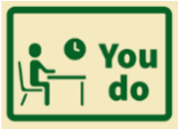
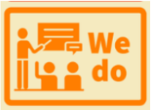
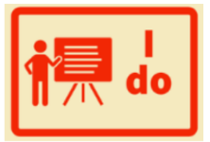

Practice problem solving question together
Activate Prior learning
Before the lesson

Problem solving
Fluency
Assess
Independent Practice
Or
Back to we
Practice the small step as a class
Model the small step
Conceptual models
Explicit narration

vOCABULARY
KIRFS
fluency warm up
Effective Curriculum mapping- Progression within and between units
AFL- Are the children ready for the next small step?
Maths Structure

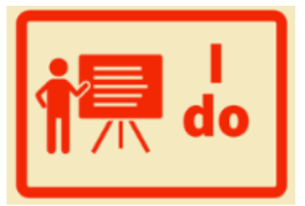 Model problem solving linked to the small step

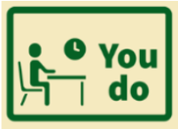
Practice problem solving question
Fluency

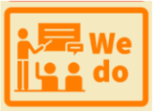 Practice problem solving question together
Assess
Next step?
Reteach

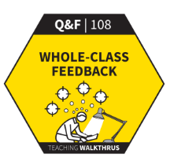
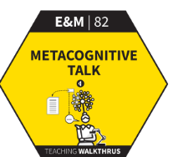
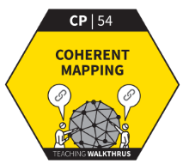
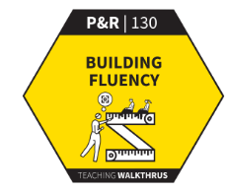
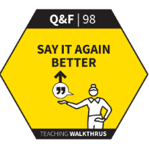
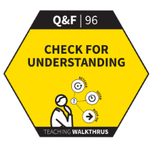
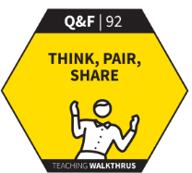
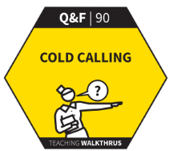
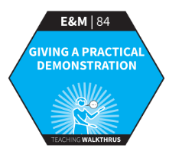
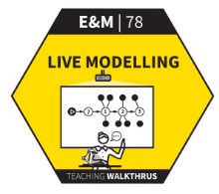
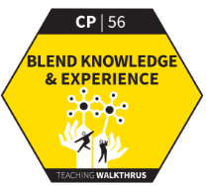
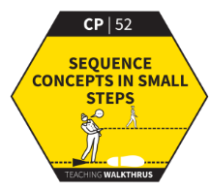
Teacher recaps and consolidates any new vocabulary learn to achieve the previously taught small steps.
Teachers introduces new vocabulary taught with alongside the next small step.
Teacher may use images to help the children hook and model to the new word.
Vocabulary
During this section, adults will include fluency which will support the children in the step being taught during the lesson.
Adults will also go through the previous taught step to reactivate the knowledge. This is quick and snappy and a reminder to the children. The adult may refer to the working wall or learning in the children’s books or iPads.
Activate Prior learning
The curriculum is carefully planned using NCETM guidance to inform each small step of learning. Concepts are broken down and sequenced thoughtfully, particularly where mixed-age classes are taught together. Lessons are structured to help children develop automaticity in these small steps through practice, while also deepening understanding by explicitly teaching problem-solving skills that build on prior knowledge.
This reflects a mastery approach, ensuring secure understanding for all learners, with additional challenge provided for those who grasp concepts quickly.
On occasions, the teacher may choose to teach a practical lesson. During these lessons you will see the three phases of learning.

Maths Structure Explained
fluency warm up
KIRFS
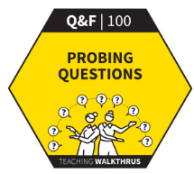
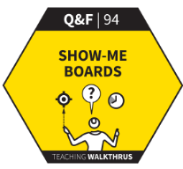
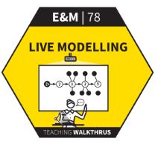
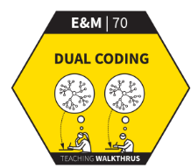
A short assessment question will be used to determine whether the children are ready to work independently. This question may take the form of a tick-box option or a multiple-choice question. Its purpose is to identify any possible misconceptions before moving on to independent practice.
.
Assess

During this stage, the teacher will work through no more than two examples with the children. These examples will focus on the same small step that was previously modelled. The process will be guided step by step, providing structured support as pupils work through each stage.
The teacher will use a range of questioning techniques to deepen understanding and move learning forward while working through the examples. Throughout this time, the teacher will continually assess pupils’ understanding to identify misconceptions and ensure progress.

The teacher begins by modelling the new step to the children. During this phase, pupils are actively listening and observing the teacher’s demonstration. The teacher narrates their thought process throughout, explicitly addressing any misconceptions that may arise when learning the small step.
To ensure understanding, the teacher may use a range of variations to illustrate the concept, providing multiple examples and approaches to reinforce the learning.

Fluency

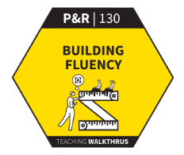
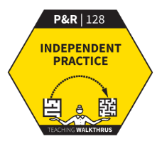
As with fluency, the teacher model a problem solving question to the children. This will be applying thee skill (small step) taught at the beginning of the lesson.

Problem solving

If children answer the assess question correctly, they move on to fluency examples following the same process as when modelled and during the ‘We Do’ section, with questions becoming progressively harder. Children will self-mark their work. If a child is answering questions incorrectly at this stage, they are to go back to ‘We Do’ with an adult.

If they answer incorrectly, they return to ‘We Do’ with the teacher who identifies the error and provides support. After this, it is essential that the child has an opportunity for ‘You Do’ before attempting problem solving. This may involve further fluency practice or joining the problem-solving activity when ready.

After the lesson, the teacher will decide on the next steps. Are the class ready to move on to the next small step? Does the class need to revisit the small step the next lesson or complete deliberate practice to gain automaticity? Are there individual children who require ither of the above?

The children then practice a problem-solving question/s on their own. This is all within the small step which has been previously taught. This may also include previously taught small steps. It is vital that the pupils have the understanding in the taught small step first before they tackle these questions. During these questions, no new learning is taught.
With the children, work through a problem solving question which adapts the same style as the ‘We Do’.
Using questioning to assess the children’s understanding. Pick out any possible misconceptions.

If a pupil does require a reteach, this will happen before the next lesson to ensure that they are building new learning on to a strong schema.

