
Personal Development Mat – Summer Term
Cardinham School
Relationships and Sex Education |   Health Education Physical and Mental | Preventative Curriculum | Online Safety | Economic Understanding | Character Development and Citizenship | Equality and Protected Characteristics | British Values | Enrichment | Sports
 |  |  |  |  |  |  |  |  | 
KS2 ‘Being Safe Workshops’  LifeWise | LifeWise  Forrest school & Wellbeing days  Sports Day  Bikeability | First Aid Basics  LifeWise  RNLI Beach safety  Police visit | Natterhub  Online Safety Newsletters | Enterprise week  Year 6 Budgeting activities  Careers assemblies  Clothing and Book sale | Eco /Green Day  Summer fair  Values assemblies  School Council  Playground leaders  Class leadership roles  Class Reward System | Reading Assemblies  Helpline Lunches | Pupil Roles  LifeWise  Reading Assemblies  School Council  School Values | TPAT Musical  Cardinham’s Got Talent  Summer Fair  DT Week  Rocksteady  Farm Trips  Residential  Author Zoom meets  School Library  Reading Volunteers | Yr 4/5/6 Swimming lessons  AS Clubs  Inter school Sports Festivals  Sports Day  Daily Mile  Dance workshops  Bikeability




Playground leaders
Daily Mile
Natterhub
School Council
Rocksteady
Pupil leadership roles


School
Value



Class reward system
Cross country
School Library
PSHE LifeWise
Reading Volunteers

Online Safety Newsletters
Black History Month

Dance Workshops
Helpline Lunches
Values Assemblies
Farm Trips
Police visit

KS2 ‘Being Safe Workshops’
Clothing and book sale
D.T Week

Reading Assemblies
ECO Green Day

RNLI Beach Safety
School
Value
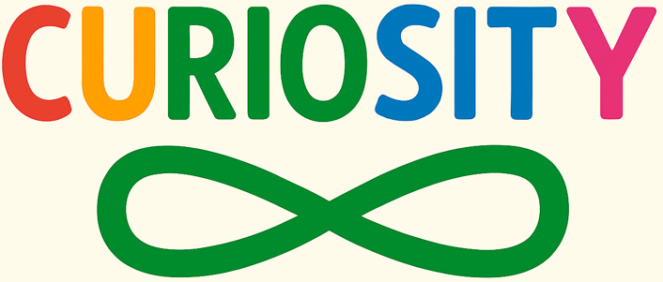
First Aid Basics
After School sports clubs

Year 6 Budgeting Activities
Yrs 4/5/6 Swimming Lessons
Author Zoom Meets
Inter-school sports festivals
Forest School & Wellbeing sessions
Cross country


TPAT Musical


Bikeability
Residential
Sports Day
Careers assemblies
Cardinham’s Got Talent


Enterprise Week
Summer Fair

Odd Sock Day

