All units are from Language Angels (pictures in plans are also from this scheme)

Year 2/3
Year B
Phonics and Pronunciation – Lesson 1 & 2

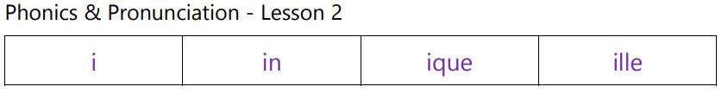

Autumn - Je peux (I am able…)
In this unit pupils will learn 10 familiar activities that they are able or are not able to do in French. This is one of the first units introducing the negative form, allowing the children to build more interesting and complex sentences including the option of using conjunctions
Programme of Study
Listening | Speaking | Reading |  | Writing | Grammar
Listen attentively to spoken language  and show understanding by joining in and responding.  Explore the patterns and sounds of language through songs and rhymes and link the spelling, sound and meaning of words. | Engage in conversations; ask and  answer questions; express opinions and respond to those of others; seek clarification and help.  Speak in sentences, using familiar vocabulary, phrases and basic language structures.  Develop accurate pronunciation and intonation so that others understand when they are reading aloud or using familiar words and phrases.  Present ideas and information orally to a range of audiences. | Read carefully and show  understanding of words, phrases and simple writing.  Appreciate stories, songs, poems and rhymes in the language  Broaden their vocabulary and develop their ability to understand new words that are introduced into familiar written material, including through using a dictionary. |  | Write phrases from memory, and  adapt these to create new sentences, to express ideas clearly.  Describe people, places, things and actions orally* and in writing | Understand basic grammar  appropriate to the language being studied, including (where relevant): feminine, masculine and neuter forms and the conjugation of high- frequency verbs; key features and patterns of the language; how to apply these, for instance, to build sentences; and how these differ from or are similar to English.
Outcomes  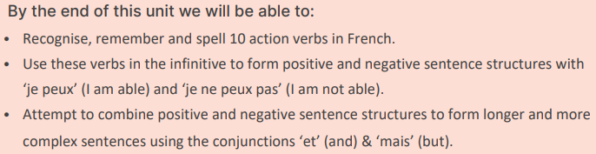 |  |  | Grammar  - To learn and revisit: Adjectival agreement.  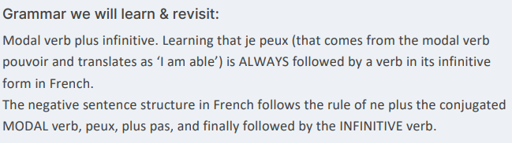
Phonics and Pronunciation  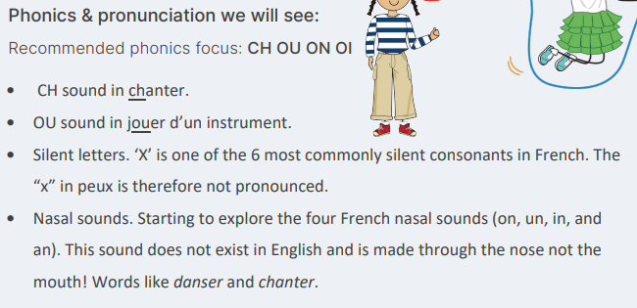 |  |  | Vocabulary  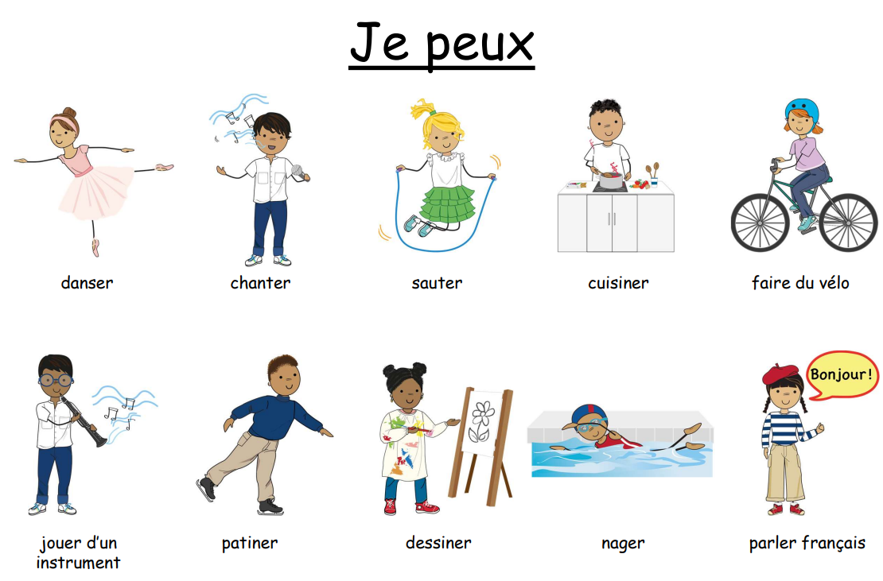  e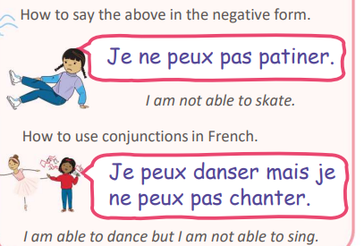

Spring - Les fruits (Fruits)
In this unit pupils will learn 10 fruits and be introduced to the simple opinions ‘I like’ and ‘I do not like’. By the end of the unit pupils will have the knowledge and skills to be able to say which fruits they like and do not like.
Programme of Study
Listening | Speaking | Reading |  | Writing | Grammar
Listen attentively to spoken language  and show understanding by joining in and responding.  Explore the patterns and sounds of language through songs and rhymes and link the spelling, sound and meaning of words. | Engage in conversations; ask and  answer questions; express opinions and respond to those of others; seek clarification and help.  Speak in sentences, using familiar vocabulary, phrases and basic language structures.  Develop accurate pronunciation and intonation so that others understand when they are reading aloud or using familiar words and phrases.  Present ideas and information orally to a range of audiences. | Read carefully and show  understanding of words, phrases and simple writing.  Appreciate stories, songs, poems and rhymes in the language.  Broaden their vocabulary and develop their ability to understand new words that are introduced into familiar written material, including through using a dictionary. |  | Write phrases from memory, and  adapt these to create new sentences, to express ideas clearly. | Understand basic grammar  appropriate to the language being studied, including (where relevant): feminine, masculine and neuter forms and the conjugation of high-  frequency verbs; key features and patterns of the language; how to apply these, for instance, to build sentences; and how these differ from or are similar to English.
Outcomes  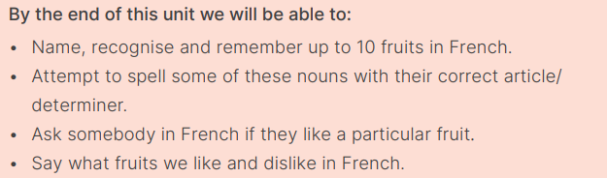 |  |  | Grammar  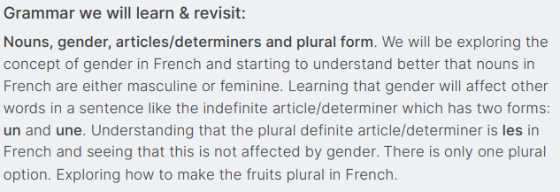
Phonics focus:  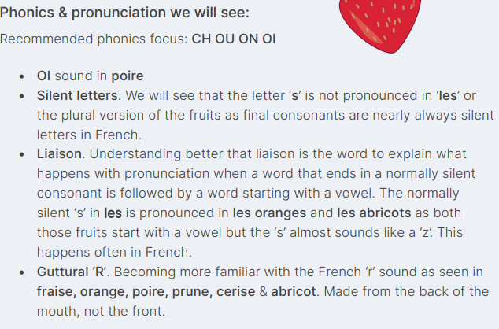 |  |  | Vocabulary  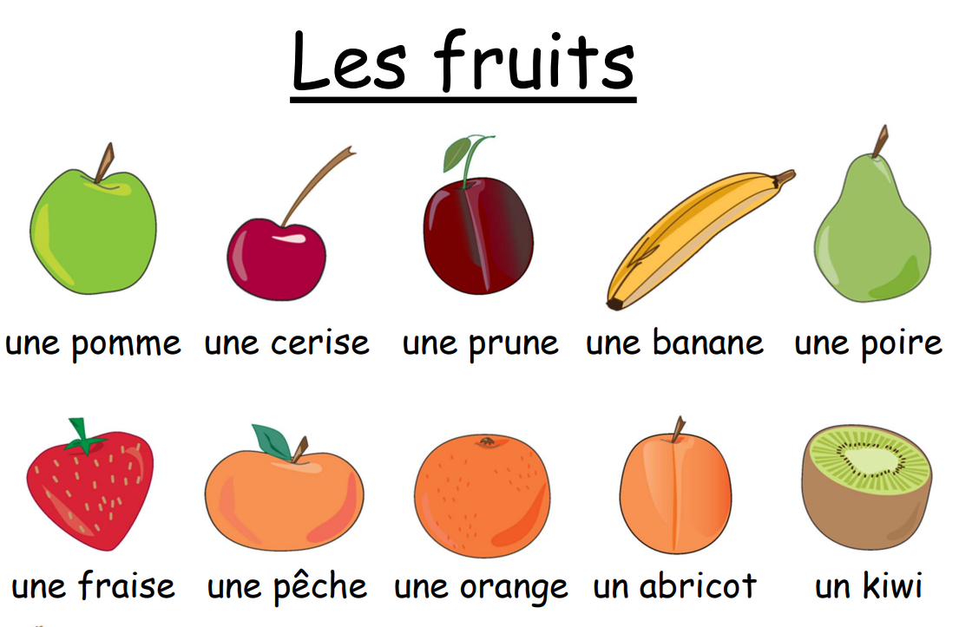  

Summer - Les animaux (Animals)
In this unit pupils will learn 10 fruits and be introduced to the simple opinions ‘I like’ and ‘I do not like’. By the end of the unit pupils will have the knowledge and skills to be able to say which fruits they like and do not like.
Programme of Study
Listening | Speaking | Reading |  | Writing | Grammar
Listen attentively to spoken language  and show understanding by joining in and responding.  Explore the patterns and sounds of language through songs and rhymes and link the spelling, sound and meaning of words. | Engage in conversations; ask and  answer questions; express opinions and respond to those of others; seek clarification and help.  Speak in sentences, using familiar vocabulary, phrases and basic language structures.  Develop accurate pronunciation and intonation so that others understand when they are reading aloud or using familiar words and phrases.  Present ideas and information orally to a range of audiences. | Read carefully and show  understanding of words, phrases and simple writing.  Appreciate stories, songs, poems and rhymes in the language  Broaden their vocabulary and develop their ability to understand new words that are introduced into familiar written material, including through using a dictionary. |  | Write phrases from memory, and  adapt these to create new sentences, to express ideas clearly.  Describe people, places, things and actions orally* and in writing | Understand basic grammar  appropriate to the language being studied, including (where relevant): feminine, masculine and neuter forms and the conjugation of high- frequency verbs; key features and patterns of the language; how to apply these, for instance, to build sentences; and how these differ from or are similar to English.
Outcomes  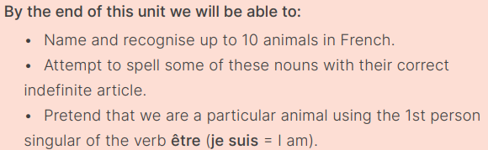 |  |  | Grammar  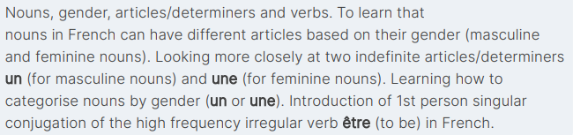
Phonics focus:  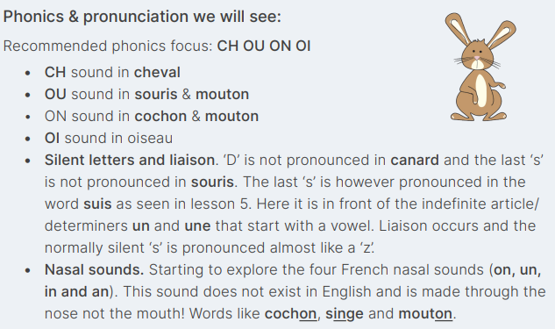 |  |  | Vocabulary  