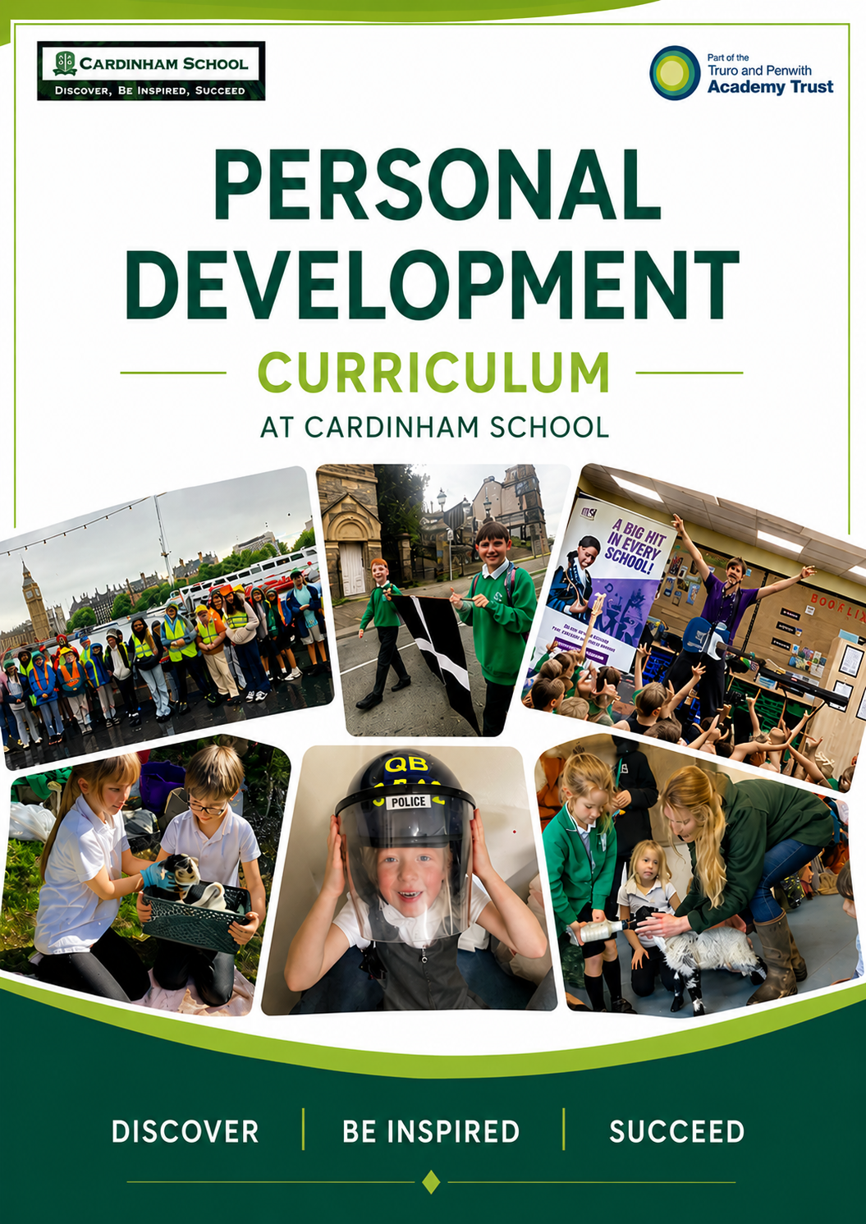

Contents

- Personal Development- 10 key areas
- Relationship and Sex Education
- Health Education Physical and Mental
- Preventative Curriculum
- Online Safety
- Economic Understanding
- Character Development and Citizenship
- Equality and Protected Characteristics
- British Values
- Enrichment
- Sports

Personal Development- 10 key areas

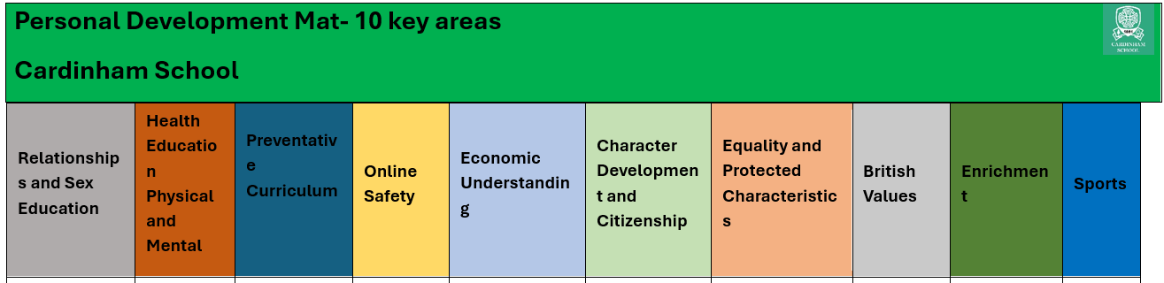


Relationship and Sex Education


At Cardinham School, we believe that Relationships and Sex Education is an important part of preparing pupils for life in modern Britain. Through RSE, children develop the knowledge, understanding and skills needed to build positive relationships, stay safe, respect themselves and others, and make informed decisions as they grow. We aim to provide pupils with age-appropriate learning that promotes wellbeing, encourages healthy relationships and supports children in understanding the changes they will experience throughout their lives.
How?
At Cardinham School, RSE is taught through the LifeWise curriculum, which provides a carefully sequenced progression of learning from EYFS to Year 6. Lessons are delivered in an age-appropriate and sensitive manner, ensuring that pupils develop their understanding gradually as they mature.
Throughout the school, pupils explore topics including friendships, families, feelings, personal safety, online relationships, physical and emotional health, and growing up. Learning is structured to build upon prior knowledge, enabling children to develop a deeper understanding of relationships, respect and responsibility as they move through the school.
Children are taught the importance of healthy and respectful relationships, recognising and managing emotions, and understanding how to keep themselves safe both online and offline. As they progress through Key Stage 2, pupils learn about the physical and emotional changes associated with puberty, ensuring they feel informed, prepared and confident for the next stage of their development.
RSE is underpinned by our school values of being Ready, Respectful and Safe and complements our wider personal development curriculum. Through open discussion, reflection and age-appropriate learning opportunities, we support pupils to become confident, respectful and responsible individuals who are prepared for life beyond primary school.


Health education Physical and Mental

At Cardinham School, health education, both physical and mental, is a central part of the curriculum, carefully planned and delivered to support every child’s wellbeing. Using the Lifewise programme as a foundation, teaching is thoughtfully structured to ensure that learning is appropriate to each child’s age and stage, helping them to build understanding and resilience over time. Teachers draw on their professional skills to deliver high-quality lessons that encourage children to reflect, share ideas, and discuss the importance of staying healthy in both body and mind. Initiatives such as Anti-Bullying Week further strengthen this focus, providing dedicated opportunities for pupils to explore kindness, respect, and emotional wellbeing. This commitment goes beyond individual lessons, as positive health practices are consistently modelled by staff and embedded into everyday provision, creating a supportive environment where children feel safe, valued, and equipped to thrive.
The primary aims of the our PSHE curriculum are to:
- Promote Health and Wellbeing: Help pupils understand physical health, mental wellbeing, diet, exercise, and how to articulate their feelings.

- Support Personal Development: Teach students to build self-esteem, self-worth, and a resilient "growth mindset".
- Ensure Student Safety: Educate children on keeping themselves safe, both physically and online (e.g., cyber awareness, recognising trusted adults).
- Prepare for the Wider World: Develop global citizens who understand diversity, local Cornish communities, fundamental British values, and basic life skills like time management.


Preventative Curriculum

The Cardinham preventative curriculum aims to equip pupils with the knowledge, skills, and understanding they need to stay safe, healthy, and resilient as they grow. It focuses on proactively addressing potential challenges by teaching children about physical and mental wellbeing, positive relationships, and responsible choices before difficulties arise. Through age-appropriate learning and consistent reinforcement, the curriculum supports children in developing confidence, self-awareness, and the ability to reflect on their actions, helping them to thrive both in school and beyond.
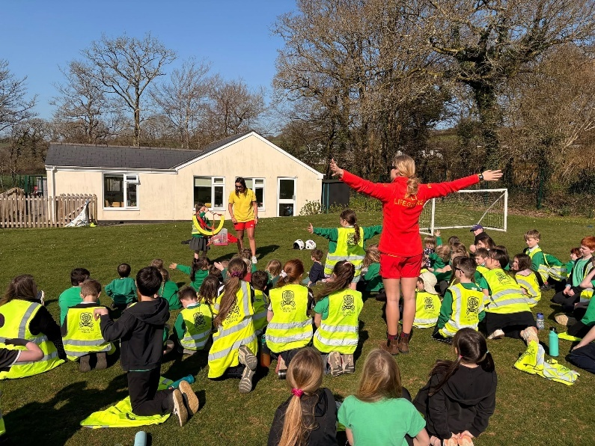
The Cardinham preventative curriculum makes strong use of Stay Safe workshops, where expert-led sessions help children understand how to keep themselves safe both in and beyond the school environment. We aim to immerse pupils in real-life learning through visits and input from a range of professionals, including the RNLI, police force, and fire service, giving them meaningful and memorable experiences. A key highlight of this approach is our dedicated Stay Safe Week in the spring term, which brings these elements together and reinforces the importance of personal safety, awareness, and wellbeing.
Key features include:
- Stay Safe workshops delivered by experts to support children in staying safe inside and outside of school
- Visits from professionals such as the RNLI, police force, and fire service
- Opportunities for children to learn directly from real-life experiences and expertise
- A focus on immersing pupils in practical, engaging safety education
- A dedicated Stay Safe Week (Spring Term) as a highlight of the curriculum

Careers Assemblies- (note- more may be added to the list as the year progresses)
Autumn 1 | Healthcare Visit
Autumn 2 | Police Service
Spring 1 | Professional Sports person
Spring 2 | Farming community
Summer 1 | Technology
Summer 2 | Art and Culture

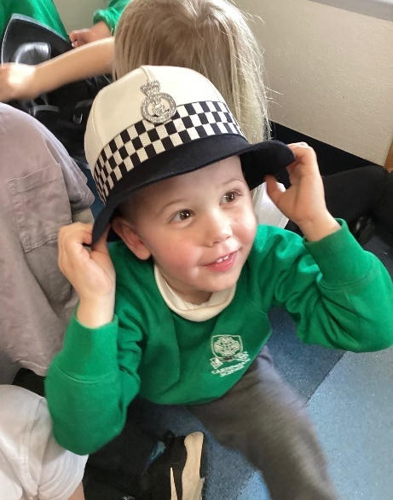
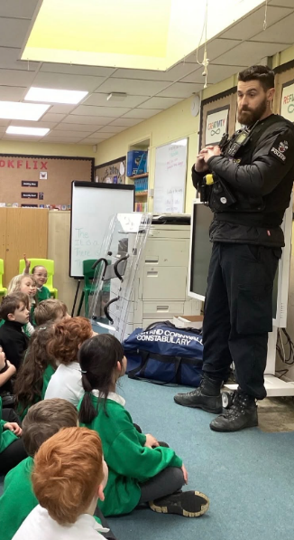
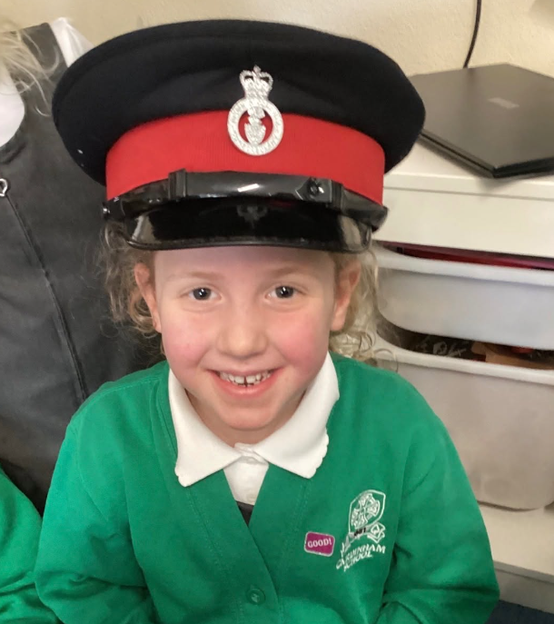


Online safety

At Cardinham School, online safety is a key priority, and its core messages are carefully woven throughout the curriculum across the entire school year. Rather than being taught in isolation, online safety is embedded into everyday learning so that children regularly revisit and build on their understanding of how to stay safe, responsible, and respectful in digital spaces. This consistent approach helps pupils develop the awareness and confidence needed to navigate the online world securely.

Natterhub as the driving programme
Natterhub is the main driver for teaching online safety at Cardinham, providing a structured and engaging framework that mirrors real-world online experiences in a safe, controlled environment. Through child-friendly characters and scenarios, Natterhub helps pupils explore important topics such as digital communication, privacy, cyberbullying, and managing screen time.
Natterhub’s values and curriculum design:
- Promotes kindness, respect, and responsibility in all online interactions
- Encourages children to think critically about their choices and behaviour online
- Supports the development of digital resilience and emotional awareness
- Lessons are carefully sequenced, building progressively on prior knowledge
- Content is age-appropriate, ensuring learning is matched to pupils’ stage of development
- Provides opportunities for discussion, reflection, and real-life application
Through this structured and values-led approach, Cardinham ensures that online safety is not only understood but actively lived by pupils as part of their everyday school experience.

Safer Internet Day is an important event in the school calendar and provides a focused opportunity to deepen pupils’ understanding of online safety. Each year, the day is marked through dedicated lessons, assemblies, and activities that explore current themes linked to safe and positive internet use. Children are encouraged to reflect on their own online behaviours, discuss potential risks, and think about how they can contribute to a safer digital community. This whole-school approach reinforces the ongoing online safety curriculum and highlights the importance of working together pupils, staff, and families to promote safe and responsible use of technology.
Tech Girls Programme
At Cardinham School, the Tech Girls programme is offered as an additional after-school club, providing girls with further opportunities to develop their understanding of online safety in a supportive and engaging setting beyond the classroom. Through this club, pupils explore key themes such as responsible online behaviour, privacy, and digital wellbeing, while building confidence in using technology safely. Activities are designed to be practical and discussion-based, enabling children to consider real-life scenarios, recognise potential risks, and make informed, safe choices online. By extending learning beyond the school day, Tech Girls strengthens the school’s commitment to ensuring all pupils are equipped with the knowledge and skills needed to stay safe in the digital world.
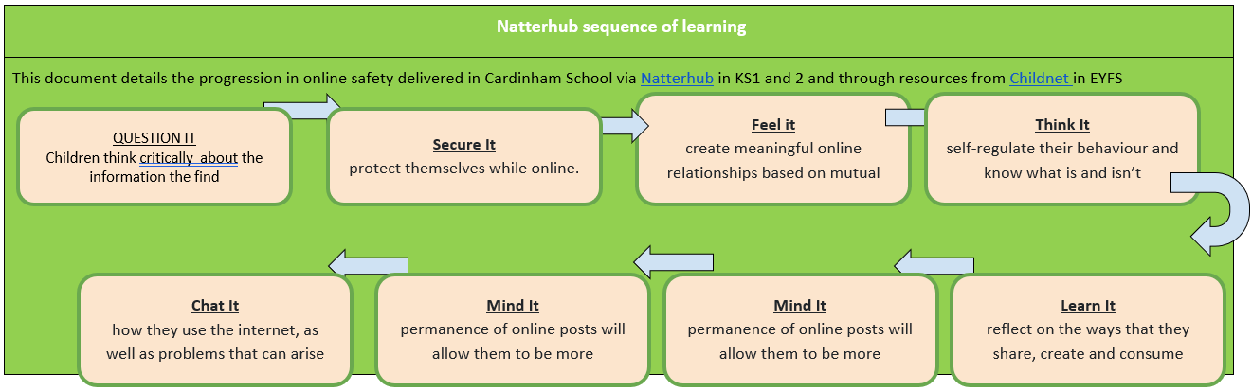


Economic Understanding

At Cardinham School, we believe that developing pupils’ economic understanding is an essential part of preparing them for life beyond primary school. Children are growing up in a world where they will regularly make decisions about spending, saving, budgeting and managing resources. By developing financial awareness from an early age, we help pupils become responsible, informed and confident decision-makers.
Economic understanding supports our wider aim of preparing children to be successful citizens who can contribute positively to their communities. It helps pupils appreciate the value of money, understand that choices have consequences and recognise the importance of planning for the future. Through meaningful real-life experiences, children learn that money is a finite resource and that careful decision-making is needed to balance wants, needs and priorities.
Our programme is further strengthened through careers assemblies and enrichment opportunities that expose pupils to a wide range of professions and employment pathways. These assemblies help children understand how people contribute to society through their work, the skills and qualities needed in different careers, and the links between education, employment and financial independence. By hearing from a variety of professionals, pupils begin to develop aspirations for the future and a greater understanding of the role money plays in everyday life.

Economic understanding is developed progressively throughout the school curriculum and through wider school experiences. Children are given opportunities to explore the value of money, discuss spending and saving choices, and consider how financial decisions affect individuals, families and communities.
Throughout the year, pupils engage in age-appropriate learning that helps them:
- Understand the value and purpose of money.
- Recognise the difference between needs and wants.
- Make informed choices about spending and saving.
- Develop an awareness of budgeting and planning.
- Understand how work and careers contribute to earning money.
- Consider how economic decisions can impact themselves and others.
These concepts are explored across the curriculum through mathematics, PSHE, enterprise activities, real-life problem-solving and careers education.
A key example of this learning can be seen in Year 6, where pupils take responsibility for planning and organising aspects of their leavers' celebration. Working within a set budget, children make collective decisions about how money should be allocated to ensure the event meets the needs of the group while remaining financially responsible. They compare costs, evaluate options, prioritise spending and consider value for money. This authentic experience provides pupils with a practical understanding of budgeting, financial decision-making and teamwork, whilst preparing them for the increased independence they will encounter as they move to secondary school.
By embedding economic understanding throughout school life, we help pupils develop the knowledge, skills and attitudes needed to make responsible financial decisions now and in the future. Through real-world experiences, careers education and practical opportunities to manage money, we equip our children with the confidence to become financially aware, responsible and aspirational citizens


Character Development and Citizenship

At Cardinham School, we believe that education extends far beyond academic achievement. Developing character and citizenship is a fundamental part of preparing children to become responsible, respectful and active members of society. We aim to nurture pupils who demonstrate kindness, integrity, resilience and empathy, whilst developing a strong understanding of their role within both their local community and the wider world.
Through opportunities to lead, serve and contribute, pupils learn that their voice matters and that they can make a positive difference to others. We encourage children to develop confidence in expressing their ideas, listening to different viewpoints and taking responsibility for their actions. By fostering these values from an early age, we help pupils grow into thoughtful citizens who are equipped to contribute positively to society.
Our commitment to character development is rooted in our school values of being Ready, Respectful and Safe. These values underpin daily interactions, decision making and relationships across the school community. Through meaningful experiences, children develop an understanding of responsibility, community, democracy, service and environmental stewardship, helping them become well-rounded individuals who are prepared for life beyond primary school.

Character development and citizenship are woven throughout school life and are developed through a range of leadership opportunities, community experiences and enrichment activities.
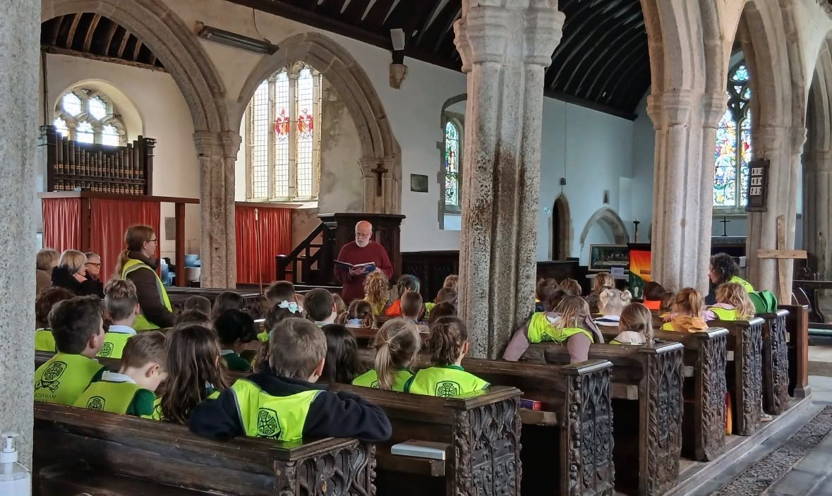
A key aspect of this work is the School Council, where elected representatives play an active role in shaping aspects of school life. Through regular meetings, consultation with their peers and collaboration with staff, pupils learn about democratic processes, representation and leadership. School Council members develop important skills such as communication, teamwork, negotiation and decision-making whilst helping to bring about positive change within the school.
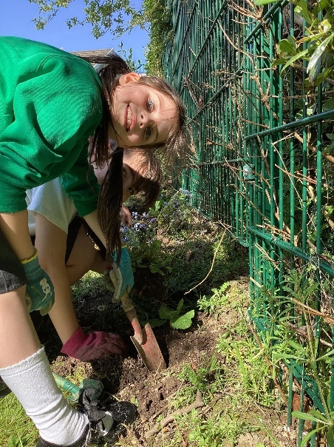
Our strong links with the local church play an important role in developing children's understanding of citizenship, community and service. Regular church visits, collective worship and participation in key Christian celebrations provide opportunities for pupils to reflect on values such as compassion, respect, forgiveness and responsibility. These experiences help children develop an appreciation of their local community, cultural heritage and the importance of supporting others.
Throughout the year, pupils participate in a range of whole-school events that promote citizenship and social responsibility. Initiatives such as Green Day encourage children to consider their impact on the environment and develop an understanding of sustainability. Through practical activities, discussions and collective action, pupils learn how small changes can contribute to protecting the world around them. These experiences help children to develop a sense of responsibility for their environment and an understanding of how they can contribute positively to their community.
Pupils also have opportunities to lead and participate in a range of child-led clubs. These clubs enable children to pursue their interests, share their talents and develop valuable life skills beyond the classroom. Whether organising activities, coaching younger pupils, leading games or sharing a particular passion, pupils develop leadership, teamwork, communication, creativity and problem-solving skills. Child-led clubs empower pupils to take ownership, demonstrate initiative and contribute positively to school life, helping them to grow in confidence and independence.
Additional opportunities, including fundraising events, community projects, remembrance activities, charitable initiatives and collaborative school events, further strengthen pupils' understanding of citizenship. Through these experiences, children learn the importance of helping others, working together for a common purpose and making positive contributions to society.
By embedding character development and citizenship throughout school life, we ensure that pupils leave Cardinham School as confident, compassionate and responsible individuals. They develop the knowledge, values and skills needed to participate positively in their communities, make informed decisions and become active citizens who embody our vision of "Growing their minds and aiming high."

Each half term, we focus on a specific value, exploring what it means, why it is important and how it can positively impact our lives, relationships and community. Through assemblies, classroom discussions, collective worship and wider curriculum opportunities, pupils reflect on how they can demonstrate the value in their daily actions both in and out of school. To deepen understanding, children also learn about influential figures from history and the modern world who have embodied these values through their actions and achievements. By examining how these individuals demonstrated qualities such as courage, perseverance, respect, compassion and integrity, pupils develop a deeper appreciation of the practical impact that positive values can have on people's lives and on society as a whole. This consistent focus helps children to develop strong moral character, make responsible choices and understand the important role they play within their community.
Autumn 1 | Autumn 2 | Spring 1 | Spring 2 | Summer 1 | Summer 2
 |  |  | 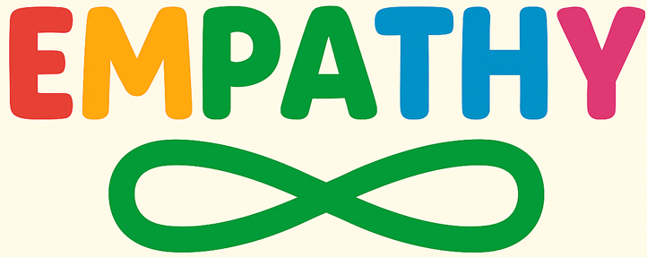 |  | 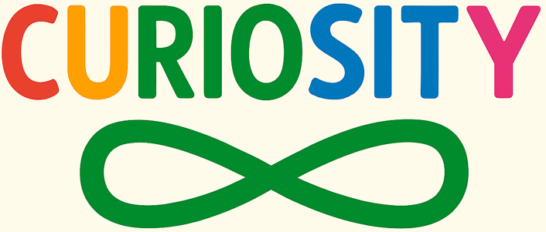

Weekly assembly yearly plan
Half Term Value | Figure | Why this person?
Collaboration | Tim Peake | Tim Peake worked with astronauts, scientists and engineers from many countries, demonstrating how collaboration helps people achieve extraordinary goals.
 | Marcus Rashford | Marcus Rashford worked alongside charities, schools and government organisations to improve support for children, showing the power of working together to create change.
Creativity | Beatrix Potter | Beatrix Potter used imagination, storytelling and illustration to create much-loved characters and stories that continue to inspire generations.
 | Leonardo da Vinci | Leonardo da Vinci combined art, science and invention, using creative thinking to explore new ideas and solve problems.
Determination | Helen Keller | Despite significant challenges, Helen Keller learned to communicate, graduate from university and advocate for others through remarkable determination.
 | Captain Sir Tom Moore | Captain Sir Tom demonstrated resilience and perseverance by raising millions for charity through determination and a positive attitude.
Empathy | Florence Nightingale | Florence Nightingale dedicated her life to caring for others and improving conditions for patients, demonstrating compassion and understanding.
 | Princess Diana | Princess Diana was known for showing kindness and empathy towards people who were often vulnerable or overlooked by society.
Reflection | Mahatma Gandhi | Gandhi encouraged people to think carefully about their actions, beliefs and choices, using reflection to guide peaceful change.
 | Nelson Mandela | After many years in prison, Nelson Mandela chose forgiveness and reconciliation, showing the importance of reflection and learning from experience.
Curiosity | Sir David Attenborough | David Attenborough's lifelong curiosity about the natural world has inspired generations to ask questions, explore and learn.
 | Mae Jemison | Mae Jemison followed her curiosity in science, medicine and space exploration, becoming the first African American woman to travel into space.

 | Autumn 1 | Autumn 2 | Spring 1 | Spring 2 | Summer 1 | Summer 2
Week 1 | 3.9.26 BV Tolerance  The only way is Badger  Transition  All are welcome | 2.11.26 BV Respect Remembrance Day  Where the Poppies Now Grow | 4.1.27 BV Law  Red Flag | 22.2.27 BV Democracy  If I were Prime Minister | 12.4.27 BV Individual Liberty  I have the right | 7.6.27 Gypsy, Roma & Traveller Week  The Can Caravan
Week 2 | 7.9.26 International Literacy Day  Luna loves Library Day | 9.11.26 Interfaith  Around the World in 80 Festivals | 11.1.27 Climate Change  Old Enough to Save the Planet | 1.3.27 World Book Day  Staff share their favourite book | 19.4.27 Deaf Awareness Week  Listen | 14.6.27 Empathy  Kindness is my Superpower
Week 3 | 14.9.26 Memory  Badgers Parting Gift | 16.11.26 Anti Bullying Week  Buster the Bully | 18.1.27 Martin Luther King Day  Little People, Big Dreams | 8.3.27 World Carers Action Day  The Invisible String | 26.4.27 Mental Health Week  Daisy’s Dragons | 21.6.27 World Refugee Week  Lubna and Pebble
Week 4 | 21.9.26 International Day of Sign Language  Listening to the quiet. | 23.11.26 Tree Week  Tree Full of Wonder | 25.1.27 LGBT+ History Month  What type of family are we? | 15.3.27 World Poetry Day  Staff share their favourite poem | 3.5.27 Cultural Diversity Week  The Proudest Blue | 28.6.27 Windrush Day  The Place for Me
Week 5 | 28.9.26 Black History Month  Little Leaders | 30.11.26 International Day of People with Disabilities  This is Me | 1.2.27 Children’s Mental Health Week  Ruby’s Worry | 22.3.27 World Autism Acceptance Week  Leo and the Octopus | 10.5.27 Cultural Diversity Week  Maya’s Walk | 5.7.27 Inspirational People  Trailblazer
Week 6 | 5.10.26 - Transition  I love Books | 7.12.26 Human Rights Day  We Are All Born Free | 8.2.27 International Dy of Woman and Girls in Science  Counting on Katherine |  | 17.5.27 Kindness / Community  Kindness Grows | 12.7.27 World Malala Day  Malala’s Magical Pencil
Week 7 | 12.10.26 - Transition  Lucy’s Blue Day | 14.12.26 International Migrants Day  Coming to England |  |  | 24.5.27 Caring for the Planet  Somebody Swallowed Stanley | 19.7.27 International Day of Friendship  Pip and Egg

Equality and Protected Characteristics 

We are committed to creating an inclusive environment where every child feels valued, respected and able to thrive. We believe that teaching children about equality, diversity and protected characteristics helps them develop respect, empathy and understanding for others. By celebrating difference and promoting inclusion, we prepare pupils to become responsible citizens who contribute positively to modern Britain.
Equality, diversity and protected characteristics are promoted through our curriculum, collective worship, assemblies and wider school experiences. A dedicated assembly thread explores the protected characteristics in an age-appropriate way, helping pupils understand the importance of fairness, respect and inclusion within society. This links into key themes and events within the rest of the country.
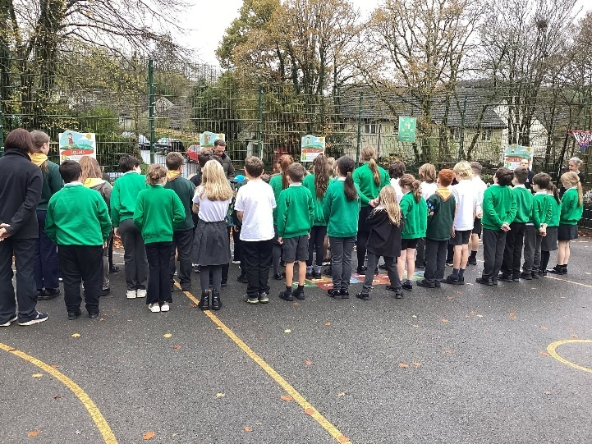
Throughout the year, pupils participate in a range of events that deepen their understanding of equality and diversity. Odd Socks Day encourages children to celebrate individuality and recognise the value of difference, whilst Remembrance Day provides opportunities to reflect on service, sacrifice, respect and community. Additional themed events and curriculum opportunities allow pupils to explore different cultures, faiths, beliefs and experiences.
Across all areas of school life, we encourage pupils to challenge stereotypes, respect differing viewpoints and recognise that everyone deserves to be treated with dignity and kindness. By embedding equality and diversity throughout our curriculum and school culture, we help children develop into respectful, inclusive and compassionate members of society.


British Values

At Cardinham School, we are committed to preparing pupils to become active, responsible and respectful citizens. Through the teaching of British Values, children develop an understanding of the principles that underpin life in modern Britain: democracy, the rule of law, individual liberty, mutual respect and tolerance of those with different faiths and beliefs. These values help pupils understand their rights and responsibilities, appreciate diversity and contribute positively to their community.

British Values are taught through our curriculum, assemblies and wider school experiences. Our assembly programme, shown above, provides a clear thread throughout the year, enabling pupils to explore how British Values are reflected in everyday life and within our school community through reading different texts.

Opportunities such as School Council elections, pupil leadership roles, community events and collaborative learning experiences allow children to put these values into practice. By embedding British Values
throughout school life, we help pupils develop into respectful, thoughtful and responsible citizens who are well prepared for life in modern Britain.

The progression of the teaching of the British Values, helps staff pitch the concept to the children.
British Value | DfE Definition | EYFS | Year 1 | Year 2 | Year 3 | Year 4 | Year 5 | Year 6
Democracy | Respect for democracy and support for participation in the democratic process. | “We all have a turn and a say.”  • Experience voting in class choices.  • Learn that everyone’s voice matters. | “Democracy means everyone gets a chance to share their ideas.”  • Take part in class decisions.  • Recognise fairness when everyone has a turn. | “Democracy is when people’s voices are listened to and decisions are made fairly.”  • Understand voting for group decisions.  • Learn that majority decision is respected. | “Democracy is about having a say and respecting the views of others.”  • Learn about school councils.  • See links between class votes and wider society. | “Democracy means people can choose who represents them and share their ideas fairly.”  • Understand elections.  • Democracy only works if people take part. | “Democracy is when people vote to make decisions and choose leaders, and everyone’s voice counts.”  • Learn about UK elections.  • Debate respectfully. | “Democracy is a system where people choose their leaders and have a say in how their country is run.”  • Explore UK Parliament.  • Why democracy matters for fairness and freedom.
Rule of Law | Respect for the basis on which the law is made and applies in England. | “Rules help us stay safe and happy.”  • Follow simple classroom rules. | “Rules are important because they keep us safe and help us know what is right and wrong.”  • Understand consequences for breaking rules. | “The rule of law means everyone follows rules to keep things fair and safe.”  • Recognise rules at home, school, playground. | “Laws are like rules for everyone in society, not just in school.”  • Learn laws apply to all people. | “The rule of law means everyone must follow the rules to protect people and make things fair.”  • Understand laws stop harm. | “Laws are rules made by government to keep people safe and protect their rights.”  • Explore consequences of breaking laws. | “The rule of law means everyone is equal under the law, and laws protect our safety, rights, and wellbeing.”  • Discuss justice and how laws are created/changed.
Individual Liberty | Support and respect for the liberties of all within the law. | “We can choose what we like and say what we feel.”  • Make choices in play and learning. | “Individual liberty means we can make choices for ourselves.”  • Understand right to choose within safe boundaries. | “Individual liberty means we have the right to make choices, but we must use them safely.”  • Balance freedom with responsibility. | “We have the right to make choices, as long as they don’t harm others.”  • Choices have consequences. | “Individual liberty is about freedom to choose and express ourselves, while respecting others.”  • People can make different choices. | “Individual liberty means we are free to make our own decisions, but we must also respect the rights of others.”  • Explore freedom of speech/expression. | “Individual liberty is about having freedoms and rights, but also the responsibility to use them fairly and safely.”  • Reflect on links with democracy and law.
Mutual Respect | Respect for other people. | “We are kind and share with our friends.”  • Learn kindness and manners. | “Respect means being kind and listening to others.”  • Respect builds friendships. | “Mutual respect means we treat others how we want to be treated.”  • Notice impact of disrespect. | “Respect means valuing other people’s ideas and feelings.”  • Show respect in discussions. | “Mutual respect means we value and care for each other, even when we disagree.”  • Respect differences of opinion. | “Respect is treating people fairly and kindly, no matter who they are.”  • Respect builds strong communities. | “Mutual respect means recognising everyone’s value and treating others with fairness and dignity.”  • Respect in wider society and global contexts.
Tolerance of Different Faiths and Beliefs | Tolerance of those of different faiths and beliefs. | “We all celebrate different things and that’s okay.”  • Learn about different festivals. | “Tolerance means learning about and accepting that people are different.”  • Notice different family traditions. | “Tolerance means we accept people who have different beliefs or ways of living.”  • Explore similarities and differences in celebrations. | “We respect and value people’s beliefs, even if they are different to ours.”  • Ask respectful questions about other faiths. | “Tolerance means welcoming diversity and treating all people equally.”  • Learn why prejudice is harmful. | “Tolerance is about respecting different religions, cultures, and ways of life in our community.”  • Explore diversity in Britain. | “Tolerance means understanding and respecting differences, and standing up against prejudice and discrimination.”  • How tolerance builds peace and fairness.


Enrichment

At Cardinham School, we believe that learning extends beyond the classroom. Our enrichment programme is designed to broaden horizons, develop talents and provide memorable experiences that inspire curiosity, confidence and aspiration. Through a wide range of opportunities, pupils develop important life skills such as teamwork, leadership, creativity, resilience and independence. These experiences help children discover new interests, build character and make meaningful connections between their learning and the wider world.

Enrichment is woven throughout school life and provides pupils with opportunities to learn, lead and succeed in a variety of contexts.
Throughout the year, pupils participate in a range of whole school events, including STEM Day, DT Week and our Whole School Trip, which provide opportunities for children to apply their learning in practical and engaging ways. These experiences encourage creativity, problem-solving, collaboration and critical thinking whilst helping pupils develop a deeper understanding of the world around them.

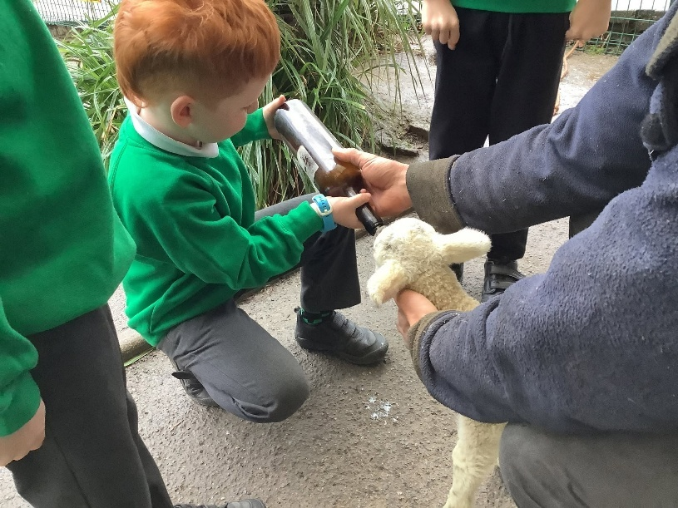
We make full use of our unique rural setting through a range of farm visits and outdoor learning experiences, enabling children to explore agriculture, sustainability and the natural environment first-hand. Residential visits further support pupils' personal development by encouraging independence, resilience, teamwork and confidence away from home.

Pupil leadership is an important aspect of our enrichment offer. Our Deer Class child-led clubs provide opportunities for pupils to pitch an idea, plan activities and run a club with support from an adult. Through this process, children develop leadership, organisation, communication and entrepreneurial skills whilst sharing their passions with others.

Cardinham's Got Talent is planned, organised and led by Deer Class pupils. From auditions and promotion to hosting the event, pupils take ownership of the process, developing confidence, teamwork and leadership skills whilst celebrating the talents of the wider school community.
By providing a rich range of experiences and opportunities, we ensure that every child has the chance to develop new skills, discover hidden talents and create lasting memories that enhance their learning and personal development.


Sports

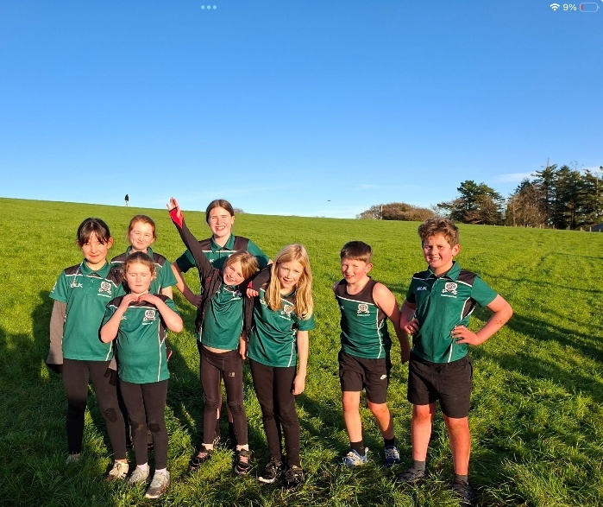
Sport and physical activity play a vital role in promoting children's physical health, mental wellbeing and personal development. Through high quality PE, competitive sport and enrichment opportunities, pupils develop confidence, resilience, teamwork and determination. We recognise the importance of encouraging children to lead active lifestyles and providing opportunities for every child to experience success, challenge themselves and represent their school with pride.
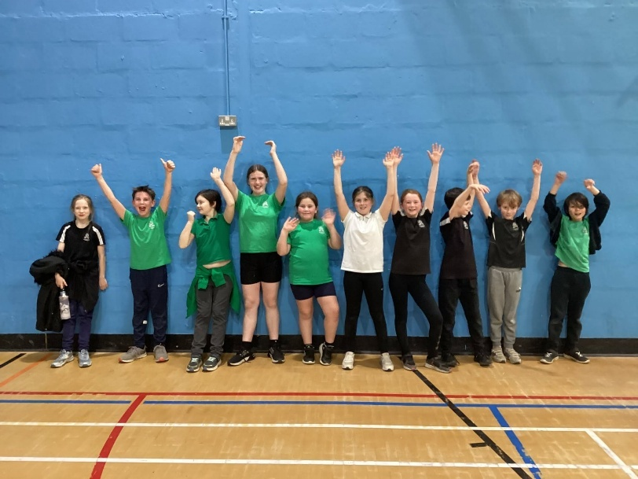
Sport is embedded throughout school life and provides pupils with a wide range of opportunities to participate, compete and develop new skills. During the Autumn and Spring Terms, pupils have the opportunity to take part in cross-country competitions, developing endurance, perseverance and resilience whilst competing against children from other schools.
Throughout the year, pupils across all age groups participate in a variety of sporting festivals and competitions hosted at Bodmin College. These events provide opportunities for children to experience different sports, develop teamwork and represent the school in a competitive environment.

We are proud to work in partnership with Plymouth Argyle, whose coaches provide high-quality coaching across a range of sports throughout the year. These sessions expose pupils to expert coaching, help develop fundamental sporting skills and inspire children to engage positively in physical activity.

Swimming is a key part of our physical education curriculum, with all pupils participating in eight weeks of swimming lessons. As well as developing water confidence and swimming proficiency, this ensures pupils gain an important life skill that supports their safety and wellbeing.

A highlight of the sporting calendar is our annual Whole School Sports Day, where pupils compete in a range of individual and team events, demonstrating determination, teamwork and sportsmanship. At the heart of the day is a family picnic lunch, bringing together pupils, families and staff to celebrate participation, achievement and our strong sense of community.

We place great importance on providing opportunities for children to compete against others and challenge themselves. Through inter-school competitions, sporting festivals, Sports Day, personal challenges and team events, pupils learn the value of effort, resilience and fair play. These experiences help children to develop confidence, celebrate success, learn from setbacks and understand the importance of working towards personal and collective goals.

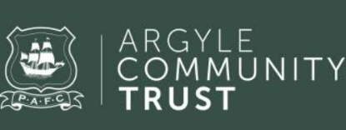
Plymouth Argyle Club list

Autumn 1 | - Football  - Cross-country  - Invasion Games
Autumn 2 | - Football  - Cross-country  - Invasion Games
Spring 1 | - Football  - Cross-country  - Multi- skills
Spring 2 | - Football  - Cross-country  - Multi- skills
Summer 1 | - Cricket  - Rounders  - Athletics
Summer 2 | - Cricket  - Rounders  - Athletics

