Core Learning - The Cardinham Way Maths

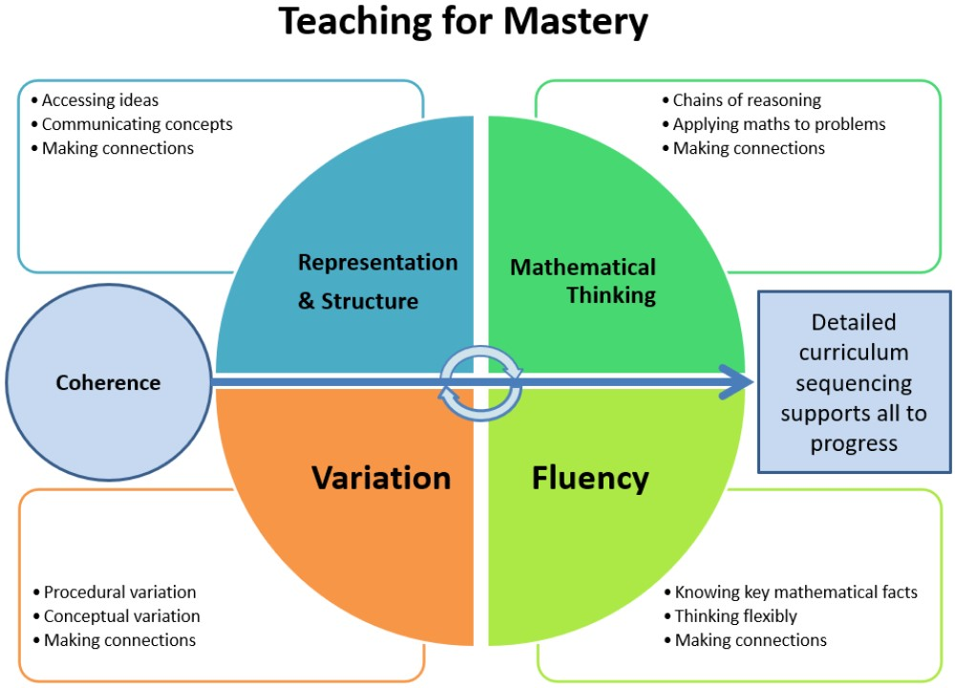

Teaching for Mastery in Mathematics: A Staff Guide

Why Teaching for Mastery?
The aim: Deep, secure understanding of maths for all pupils.
Traditional approaches often prioritise pace, coverage, and getting “through the curriculum.” Mastery slows things down to go deeper, ensuring every child truly understands key concepts before moving on.
This approach is grounded in international research (notably from Shanghai and Singapore) and is supported by the NCETM, Maths Hubs, and the DfE as best practice.

🔑 The 'why':
- Equity: All children are capable of achieving in maths.
- Depth over speed: Pupils who understand more deeply make more progress over time.
- Prevents gaps: By securing concepts before moving on, fewer pupils fall behind.
- Long-term retention: Ideas are embedded and connected, not crammed and forgotten.

What Is Teaching for Mastery?
Teaching for mastery includes five key features (defined by the NCETM in the diagram above):

1. Coherence
Carefully sequenced lessons that build small steps of understanding. Each step leads clearly to the next.

2. Representation and Structure
Concrete and pictorial models (like base 10, bar models, number lines) reveal the structure of maths, not just the answer.

3. Mathematical Thinking
Children reason, spot patterns, make connections, explain, and justify — not just do procedures.

4. Fluency
Quick, accurate recall of number facts and procedures — but with understanding, not rote learning.

5. Variation
Tasks and questions are varied in small, purposeful ways to highlight mathematical relationships — not just repetition.
How Does It Look in Practice?

🔹 Lesson Design
- One clear learning point per lesson (a small step).
- Taught through guided, scaffolded practice — not long input, then “go and do”.
- Use of stem sentences (e.g., “If I know 7 + 3 = 10, then I know 70 + 30 = 100”) to promote reasoning and generalisation.
- Questioning is central: “How do you know?”, “Can you explain it a different way?”, “What’s the same/different?”

🔹 Whole-Class Teaching
- All children work on the same concept together.
- Differentiation through depth, not acceleration — more challenge comes from thinking harder, not learning ahead.

🔹 Use of Manipulatives and Representations
- Tools like counters, ten frames, dienes, bar models etc. are used in all year groups — not just in KS1 or for SEND pupils.
- Visuals are used to develop understanding, not as decoration or gimmicks.

🔹 Practice and Variation
- Pupils engage in intelligent practice — questions that change gradually to deepen understanding.
- E.g., 4 + 3 → 14 + 3 → 14 + 13 — exploring patterns and structure.

🔹 Same-Day Intervention (if possible)
- Pupils who don’t grasp the concept receive support the same day to keep up, not catch up.

Deep Dive into the Teaching for Mastery Model
The NCETM defines five key dimensions of teaching for mastery:

1. Coherence
“Every lesson builds carefully and deliberately from the last.”

What it means:
Coherence is about carefully sequencing learning in small, connected steps. Teachers deliberately plan each lesson to build on prior knowledge and lead logically into the next. Rather than “covering” content, we build understanding step by step.

How to implement:
- Use small steps: Teach one clear concept at a time — e.g., before teaching 4 + 3, make sure pupils can subitise 4 and 3, and understand combining groups.
- Anticipate misconceptions: Know the “wrong turns” pupils may take, and build in opportunities to address them.
- Plan for key questions: What do pupils need to know and see to understand this step?

Example:
In Year 2 addition:
- Step 1: Add two numbers within 10 using ten frames.
- Step 2: Add across 10 (e.g., 8 + 5) using part-whole models.
- Step 3: Add two 2-digit numbers not crossing 10.
- Step 4: Add two 2-digit numbers crossing 10, with base 10 blocks.
Each builds understanding and prepares for the next.

2. Representation and Structure
“Maths is about relationships. We make them visible.”

What it means:
Pupils learn best when they can see the maths. We use representations (physical or visual tools) to highlight the underlying structure of a concept — not just to “help” but to expose meaning.

How to implement:
- Consistent models: Use agreed representations across year groups (e.g., bar models for part-whole, number lines for addition).
- Concrete → Pictorial → Abstract (CPA): Move from hands-on (counters) to pictures (drawn ten frames) to symbols (4 + 3).
- Don’t rush to abstraction: Pupils should be confident with concrete and pictorial representations before focusing purely on numbers.

Example:
To teach division:
- Concrete: Share 12 cubes into 4 equal groups.
- Pictorial: Draw 4 circles and place 3 dots in each.
- Abstract: Write 12 ÷ 4 = 3.
This helps pupils see division as sharing, and later link to inverse operations.

3. Mathematical Thinking
“If children aren’t thinking, they aren’t learning.”

What it means:
Children need to reason, explain, predict, and connect ideas. Mastery lessons aren’t just about getting answers — they are about exploring structure and logic.

How to implement:
- Use sentence stems: e.g., “I know ___ because ___”; “I notice that…”; “If ___ then ___”.
- Encourage reasoning: Ask, “How do you know?”, “What’s the same and different?”, “Can you prove it?”.
- Promote pattern-spotting: Children need to identify and talk about mathematical structures.

Example:
In KS1:
- "If 5 + 2 = 7, what do you think 50 + 20 is? Why?"
In KS2:
- "If I multiply by 10, the digits move — why does that happen?"
This develops relational understanding, not just recall.

4. Fluency
“Quick and accurate recall, built on deep understanding.”

What it means:
Fluency is not just speed. It’s about flexibility, efficiency, and accuracy. Pupils should know number facts but also how and why they work — so they can apply them in new contexts.

How to implement:
- Fluency with understanding: Don’t drill without first understanding the structure behind facts (e.g., use ten frames to show why 6 + 4 = 10).
- Frequent practice: Short, regular sessions to recall key facts (e.g., number bonds, times tables).
- Multiple strategies: Teach and compare different methods (e.g., number line vs. column addition).

Example:
Rather than just chanting “3 x 4 is 12,” pupils:
- Show 3 groups of 4 with counters.
- Draw an array.
- Recognise that 3 × 4 = 4 × 3.
- Connect to repeated addition (4 + 4 + 4).
Fluency is built through this rich diet of methods.

5. Variation
“Carefully designed sequences that reveal patterns and generality.”

What it means:
Variation is about how examples are chosen. We don’t just give random questions. We vary them in small, deliberate ways to highlight what’s important and expose structure.
There are two types:
- Conceptual variation: Show the same idea in different forms.
- Procedural variation: Change one element at a time in a set of examples to highlight patterns.

How to implement:
- Choose tasks that promote noticing: e.g., “What’s changed from this example to the next?”
- Expose non-examples: e.g., “Which of these is not a square number, and why?”
- Use ‘What’s the same? What’s different?’: This encourages comparison and reasoning.

Example:
If teaching subtraction:
- 13 – 5
- 13 – 6
- 13 – 7
Children notice that as the number subtracted increases, the answer decreases.
Or:
- 8 – 3 = 5
- 18 – 3 = 15
- 28 – 3 = 25
Pupils see the pattern and apply it across place value.

Summary: What It Looks Like in School
Element | What Staff Do | What Pupils Do
Coherence | Plan small, logical steps | Build ideas gradually
Representation | Use concrete and pictorial tools | Visualise and explain
Thinking | Ask deep, open questions | Reason, explain, justify
Fluency | Build number sense and confidence | Recall and apply facts efficiently
Variation | Design purposeful examples | Spot patterns, make connections

Perfect Teaching for Mastery Maths Lesson Design

1. Clear, Small Learning Objective (LO)
- The lesson focuses on one key idea or concept, a small step in the progression.
- This LO is shared with pupils in simple language and revisited throughout.
- Example: “Today we will learn how to add two 2-digit numbers without crossing 10.”

2. Recap and Recall
- Start by reviewing previous learning relevant to today’s concept.
- Use short, quick questions or activities to activate prior knowledge.
- Example: Rapid-fire recall of number bonds to 10, or simple addition facts.
Why? To build fluency and link new learning to what they already know.

3. Concrete/Pictorial Introduction
- Introduce the new concept using concrete manipulatives (e.g., base 10 blocks) or pictorial models (e.g., tens frames, bar models).
- Teacher models the concept step-by-step with clear explanation and thinking aloud.
- Pupils physically handle materials or draw alongside.
Example:
Teacher shows 23 + 45 using base 10 blocks: 2 tens + 3 ones and 4 tens + 5 ones. Then demonstrates grouping ones to make a ten.
Why? Concrete and visual experiences help pupils internalize abstract concepts.

4. Guided Practice and Reasoning
- Pupils work through carefully sequenced questions together as a class.
- Teacher asks open questions:
  - “What do you notice about the ones column here?”
  - “Why do we need to regroup?”
  - “Can you explain how you worked this out?”
- Use stem sentences to encourage full explanations and mathematical language.
Example Questions Sequence:
- 12 + 35 (no regrouping)
- 27 + 34 (regrouping ones)
- 48 + 27 (regrouping tens and ones)
Why? To deepen understanding and build reasoning skills.

5. Independent/Partner Practice with Variation (15 minutes)
- Pupils try a series of questions varying one element at a time (variation principle).
- Work may be done individually, in pairs, or small groups.
- Teacher circulates, listens, and gives same-day intervention where needed.
- Challenge tasks extend deeper reasoning, not just harder numbers.
Example Variation:
- 54 + 23
- 54 + 28
- 54 + 38
- How does changing the ones digit affect regrouping?
Why? To consolidate and apply the concept with growing confidence.

6. Reflection and Consolidation
- Bring the class back together to discuss key points and misconceptions.
- Ask pupils to explain in their own words or write a sentence about what they learned.
- Recap the learning objective and check understanding.
Example:
- “Who can explain why we sometimes need to carry over a ten?”
- “What helped you understand today’s lesson?”
Why? Reflection embeds learning and encourages metacognition.

7. Assessment and Feedback
- Use questioning, work scrutiny, or quick quizzes to gauge understanding.
- Provide immediate feedback or plan same-day/same-week support for those struggling.
- Record observations to inform future planning.

Key Features to Include Throughout:
- Whole-class teaching: All pupils work on the same concept, with differentiation through depth, not different content.
- Use of precise mathematical language: Teachers model and expect use of correct vocabulary.
- Encouraging mistakes as learning opportunities: Discuss misconceptions openly.
- Pace: Steady, not rushed — prioritizing depth over breadth.
- Multiple representations: Concrete → pictorial → abstract as needed.
- Collaborative talk: Partner or group discussion to verbalize reasoning.
More Detail on Lesson Design:

1. During the Concrete/Pictorial Introduction
- Pupils reason as they explore manipulatives and models:
“Why does regrouping work this way?”
“What do you notice about these tens and ones?”
- Teachers model reasoning aloud: “I see 13 + 29. If I make 13 into 10 + 3, what can I do with the 3 and the 29?”

2. Guided Practice
- This is the core reasoning phase:
  - Open-ended questions like “How did you work that out?” or “Can you prove it?”
  - Asking pupils to explain patterns they notice across examples.
  - Challenging pupils to predict what will happen if a number changes.
- Pupils learn to justify answers and discuss multiple methods — that’s reasoning in action.

3. Independent/Partner Practice
- Problem-solving tasks are embedded here:
  - Carefully designed questions that vary parameters to make pupils think deeply (variation principle).
  - “What’s the same and what’s different?” style questions to provoke comparison and reflection.
  - Multi-step problems that require applying the concept in new ways.
- Pupils discuss ideas with partners, explaining reasoning to each other.

4. Reflection and Consolidation
- Pupils articulate why methods work, not just how.
- They tackle reasoning questions like “Why does this method always work?” or “Can you think of a problem where this strategy wouldn’t work?”
- This phase helps develop metacognition — thinking about their thinking.

5. Problem Solving as a Spiral Feature
- Across lessons and units, problem solving is spiralled in alongside skill development, not postponed.
- Tasks are chosen to challenge reasoning, e.g., puzzles, investigations, “What if” scenarios.
- Teachers ensure that problem solving is accessible for all through scaffolding, but deep enough to stretch those ready for it.

Example:
If teaching addition with regrouping:
- Reasoning questions: “Why do we put the extra ten in the tens column?”
- Problem-solving: “If I have 27 + 15, and I want to check my answer, how could I do that?”
- Challenge: “What happens if the ones column adds to exactly 10? How would that change what we do?”

Summary
Reasoning and problem solving are not “bolt-ons” but threaded through every part of the lesson via:
- Thoughtful questioning
- Opportunities to explain and justify
- Variation that encourages pattern-spotting
- Collaborative talk and discussion
- Application in unfamiliar contexts

Ensuring Coverage of Reasoning and Problem Solving for All:

1. Integration over Separation
- From the start, reasoning and problem solving are woven into each lesson alongside skill teaching.
- Pupils reason about the skill as they’re learning it, applying and exploring it deeply.
- This keeps maths meaningful and connected rather than fragmented.

2. Skill Consolidation Followed by Application
- Once a skill is secure (pupils can fluently perform it with understanding), you might design lessons or activities that focus more heavily on problem solving and reasoning that require applying that skill in varied or unfamiliar contexts.
- These lessons reinforce and extend learning, often using more open-ended or multi-step problems.

3. Dedicated Problem Solving Weeks or Sessions
- Some schools choose to have periodic blocks (e.g., a problem-solving week) or regular sessions (e.g., weekly problem-solving lessons) where pupils tackle rich problems across topics — promoting reasoning, perseverance, and mathematical thinking.
- These don’t replace mastery lessons but complement them.

Why not fully separate them?
- Separating problem solving risks treating it as an “add-on” or a less important part of maths, rather than a core part.
- When reasoning and problem solving are embedded from the start, pupils develop these skills naturally as part of learning maths, rather than as a bolt-on.

Practical example:
- In early lessons on addition, pupils use reasoning daily (“Why does this method work?”).
- Once addition strategies are embedded, a later lesson might focus on problem-solving puzzles that require combining addition, subtraction, and reasoning skills in real-world contexts.

“I do, We do, You do”
The “I do, We do, You do” model is a widely used instructional framework, especially effective in teaching mastery concepts. It’s a gradual release of responsibility model that guides learners from teacher-led demonstration to independent practice.

I Do — Teacher Modelling
- The teacher demonstrates the concept or skill clearly.
- Think-aloud to show how and why something is done.
- Pupils watch and listen — no pressure to produce yet.
- Example: Teacher solves a problem step-by-step, explaining reasoning aloud.
- Heavily centres on metacognition – breaking every thought down to a class

We Do — Guided Practice
- Teacher and pupils work together on similar problems.
- Pupils begin to apply the concept with scaffolding.
- Teacher asks questions, prompts reasoning, and supports mistakes.
- Example: Teacher leads the class through a problem, encouraging discussion and explaining reasoning as they go.

You Do — Independent Practice
- Pupils work independently or in pairs to apply the skill.
- Teacher monitors, giving feedback and support as needed.
- The goal is fluency and confidence.

Why it fits well with Teaching for Mastery
- Supports small step learning and coherence by gradually releasing responsibility.
- Encourages reasoning during guided practice (We do), not just during independent work.
- Ensures pupils internalize concepts with support before being asked to work independently.
- Allows for immediate intervention if pupils struggle.

The “I do, We do, You do” model isn't meant to be a rigid sequence — it’s a flexible structure that supports responsive teaching. Think of it as a rhythm, not a straight line. Teaching for mastery thrives when that rhythm allows space to:
- Check understanding
- Respond to misconceptions
- Loop back when needed
- And crucially, embed reasoning throughout

Here's how it works in practice:
Instead of:
I do ➡ We do ➡ You do ➡ Done
You get something more like:
I do ➡ We do ➡ You do ➡ (uh oh) Misconception? ➡ Back to We do ➡ I do (again, with a new example) ➡ You do ➡ Now Reasoning ➡ We do (with partner talk) ➡ Problem Solving task ➡ You do ➡ Reflect

Teaching is Iterative, Not Linear
- “I do” happens multiple times in a lesson — each time you model a different representation, a new variation, or introduce more complexity.
- “We do” can be revisited mid-lesson when pupils get stuck during independent practice.
- “You do” is phased in gradually, not thrown at pupils after one example — some may be ready sooner than others.
- Reasoning often begins in “We do” and gets deepened in “You do”, then reflected on at the end.

Mastery Teaching is Responsive
A mastery lesson is not tight and inflexible — it’s tight in design, but flexible in delivery.
The key is:
- Well-planned small steps
- Deep understanding of the concept, not just the procedure
- Teacher responsiveness — re-looping as needed without rushing through

Example: Year 3 Partitioning (Lesson snippet)
- I do: Model partitioning 356 as 300 + 50 + 6 (place value counters)
- We do: Partition 472 together, discussing which counters go where
- You do: Children try 835 independently
- ❌ Misconception: Some pupils put “800” in the tens
- Back to I do: Teacher shows correct representation again
- We do (again): Class talks through 763
- You do: Try again with 902
- Reasoning: “Can you find two numbers with the same digits but different values?”
- We do: Discuss and explore with a partner
- You do: Try a reasoning task independently

Flexible Mastery Lesson Structure (KS1 / KS2)

✅ 1. Prior Learning Reactivation (5 mins)
- Retrieval task (flashback 4, short quiz, paired talk, etc.)
- Activates declarative or procedural knowledge linked to today’s concept.
“What did we learn yesterday that might help us today?”

✅ 2. Anchor Task / Conceptual Hook (5–10 mins)
- A problem, image, or context that makes the concept meaningful
- Can be reasoning-based: “What do you notice?” “What’s the same/different?”
E.g., Show a bar model or dienes and ask: “What number is represented?”

✅ 3. I Do (Initial Explanation & Modelling – 5–10 mins)
- Clear, precise modelling using concrete/pictorial representations
- Stem sentences used to verbalise mathematical structure
- Avoid multiple strategies upfront – focus on one clear method
“356 is made of 3 hundreds, 5 tens and 6 ones. I know this because…”

✅ 4. We Do (Guided Practice – 10–15 mins)
- Teacher + pupils solve examples together
- Vary examples to highlight key features (variation)
- Include partner talk, whiteboards, reasoning questions
“What mistake might someone make here?”
“How is this example different from the last one?”

✅ 5. You Do (Independent Practice – 10–20 mins)
- Starts scaffolded → gradually more open
- Pupils work on a mix of fluency and reasoning
- Teacher circulates for responsive support
“Try these fluency examples, then choose a reasoning challenge.”

🔁 6. Re-loop if needed (any time during lesson)
- If misconceptions arise:
  - Go back to We Do or I Do
  - Use a new model or variation
  - Revoice a concept with different language

✅ 7. Reasoning & Problem Solving (5–10 mins)
- Pupils explain, justify, or apply
- Can be in pairs, whole-class discussion, or independent
“Can you find two different ways to represent 476?”
“Which one doesn’t belong? Why?”
“Always, sometimes, or never true?”

✅ 8. Reflection & Exit Check (2–5 mins)
- Recap key learning (use sentence stems, hinge question, etc.)
- Exit ticket, mini quiz, or pupil self-assessment
“What have you learned today that you didn’t know before?”
“How confident are you with today’s learning?”

🧠 Visual Diagram (Optional Layout):
Reactivate → Hook → I Do → We Do → You Do → Loop as Needed → Reasoning → Reflect

📁 Want it as a downloadable template?
I can create a printable or editable version in Word or Google Docs format if you'd like to roll it out to staff. Would that be helpful?

Additional Elements You Might Add

Year 2 and Year 3

Include in here

Year 4, Year 5 & Year 6

Learning by Questions | LbQ

1) Login

Username: djones@cardinham.tpacademytrust.org
Password: C@rd1nham24

2) Click on the schemes

Understanding

Fluency

Reasoning (fed throughout)

Problem solving (fed throughout)

I do – metacognition

We do – partner talk/group/class input

You do -
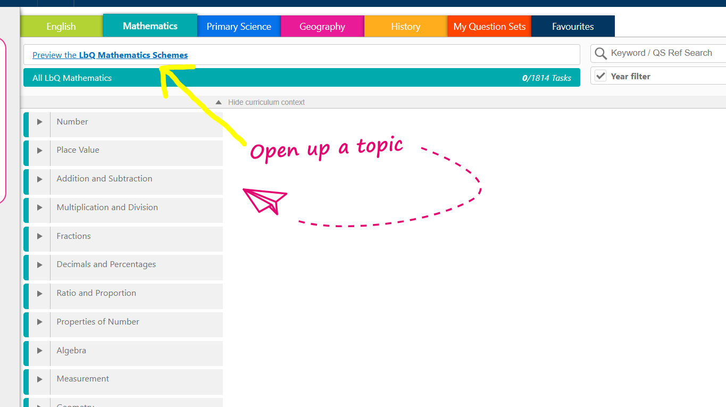

3) As discussed, click through the schemes and see which is most transferrable to our current curriculum for Year 5/6.

4) What are general thoughts on how this resource could be used for a Year 4/5/6 class.

5) Could some units be used as a fluency type activity?

6) What next? Do we need to look at writing a new whole school curriculum? Could we split the year ¾ curriculum and then ‘bolt on’ the year 4 curriculum to Year 5/6? And bolt on the Year 2 to the Year 3?

To Dos
- Agree on WALTs
- Agree on consistent lesson design
- Agree on format for documents
- Agree on book expectations
- Agree on lesson resourcing (layout)
- Agree on fluency plan for afternoon
- Consistency:
  - Agree representations
  - Agree manipulatives
  - Agree calculation policy
- How do we layout challenging?

Section | Purpose | Why it helps
Key Representations | Lists the concrete/pictorial/abstract tools used (e.g. place value counters, bar models). | Ensures consistency and mastery-style progression from concrete to abstract. Prevents tokenistic use of manipulatives.
Variation Guidance | Notes how to vary examples to expose structure. | Supports teachers in designing examples that reveal mathematical relationships, not just ‘more practice’.
Same Day Intervention Opportunities | Suggestions for quick support activities. | Helps staff plan support for pupils who don’t ‘get it’ the first time, in line with mastery’s “keep up, not catch up”.
Links to Future Learning | Shows how this concept underpins what's coming next. | Encourages teachers to build conceptual bridges and avoid teaching in isolation.

