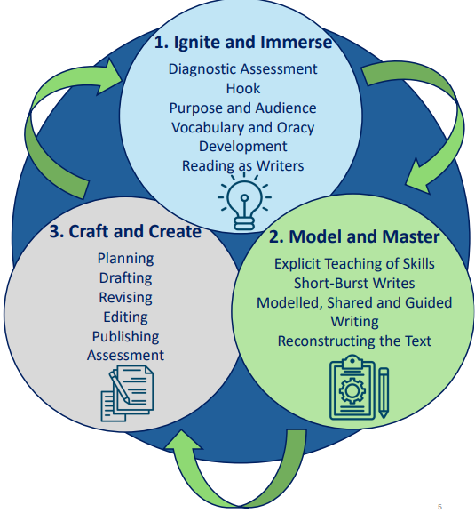

Children practice foundational skills through dictated sentences
Children self-mark
Live marking by adults
Foundational skills
Dictated sentence
Grammar starter
Practice the small step as a class
Before the lesson

Diagnostic assessment
What section of the English sequence am I teaching?
English Structure

English teach

Assess Next step? Reteach

