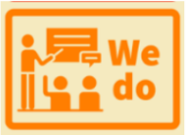
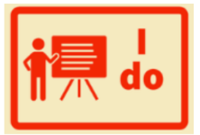

Fluency

vOCABULARY
Before the lesson

Practice the small step as a class
Grouping of the children
What is the focused based on assessment?
What are the vocabulary gaps?
Reading Fluency Structure
Partner 1 to partner 2
Partner 2 to partner 1

Comprehension
Comprehension

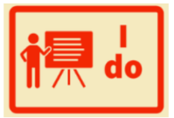
Teacher models the question

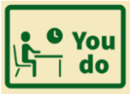
Children independently answer a question as previously modelled

Teacher models the next question type

Children independently answer a question as previously modelled
Assess
Is fluency improving?
What question type do I need to focus on next?

