Year 1 | Autumn 1 | Autumn 2 | Spring 1 | Spring 2 | Summer 1 | Summer 2
School Value | Determination  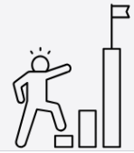 | Empathy  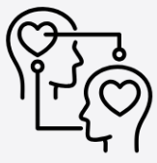 | Collaboration  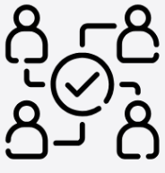 | Creativity   | Curiosity   | Reflection  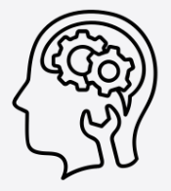
British Value | Democracy  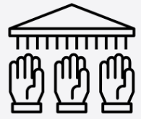 | Mutual Respect  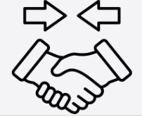 | Tolerance of those of Different Faiths and Beliefs  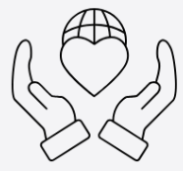 | The Rule of Law   | Individual Liberty  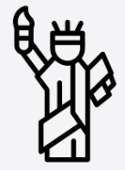 | Recap
LifeWise Units | 1.Being Happy x 2  2.Being Mindful x 2  3. First Aid and CPR x 2  4. What is Friendship | 1.Getting your sleep x 2  2. Hygiene and Me x 2  3.Understanding Difficult Feelings x 2  4.Kind vs Unkind | - A Problem Shared is a Problem Halved  - Communication x2  - Trust x2 | 1.What Makes A Family  2.My Growing Body  3. Respecting Others x  4. Water Safety | 1.Braving the Weather x 2  2.Emergency Services x 2  3.Food Safety and What Not to Eat x 2  4. Wildlife | - Road Safety x 2  - Safety Symbols x 2  - Signalling and Sign Language
Sequence of Learning | 1. To describe when they felt happy  To understand what makes them happy  To recognise the feeling of happiness and can describe how happiness makes them feel  To know why happiness is important  To understand how we can feel happier  2. To know what it means to be mindful.  To know why being mindful is good for us.  3.To know what to do when we see someone who is injured  To know what to do when a person isn’t breathing.  To know how we might give First Aid or CPR (Cardiopulmonary Resuscitation).  4. To learn about how people make friends and what makes a good friendship.  To learn how to recognise when they or someone else feels lonely and what to do. | 1. To know what is the right amount of sleep.  to know the impact that sleep has on us  To know that sleep helps our mind and body.  2.To learn about personal hygiene routines and habits;  To learn that personal hygiene can help us stay about dental care and visiting the dentist;  how to brush teeth correctly;  to know which food and drink that support dental health.  3. To understand anger and difficult feelings.  To know how to control our anger.  4. To know that bodies and feelings can be hurt by words and actions; that people can say hurtful things online.  To understand how people may feel if they experience hurtful behaviour or bullying.  To know that hurtful behaviour (offline and online) including teasing, name-calling, bullying and deliberately excluding others is not acceptable; how to report bullying; the importance of telling a trusted adult.  To know what is kind and unkind behaviour, and how this can affect others | 1. To understand the outcomes of sharing a problem.  To find the best ways to help with problem  2. To understand why it’s important to have good communication skills in life.  To know how to communicate in tricky situations.  3..To understand the importance of trusting someone  To know who we can trust  To understand how important it is to be trusted | 1. To learn about different types of families including those that may be different to their own.  To develop an understanding about the roles different people (e.g. acquaintances, friends and relatives) play in our lives.  To recognise the ways they are the same as, and different to, other people.  2. To recognise that some things are private and the importance of respecting privacy; that parts of their body covered by underwear are private.  To name the main parts of the body including external genitalia (e.g. vulva, vagina, penis, testicles).  To know about growing and changing from young to old and how people’s needs change  3. To know what respect is.  To know why respect is important.  4. to understand how you can be safe in water | 1. To know that there are different types of weather.  To know how the weather can affect us.  To know that sometimes the weather can be dangerous.  3. To name the 3 main emergency services.  4. To know how the 3 main emergency services can help us. Know what an emergency is and what to do in an emergency.  5. Know what we would do if we needed help but it wasn’t an emergency.  To understand which foods can be dangerous if we eat them.To know what to do if someone has eaten unsafe foods About things they can do to help look after their environment.To recognise risk in simple everyday situations and what action to take to minimise harm. Ways to keep safe in familiar and unfamiliar environments (e.g. beach, shopping centre, park, swimming pool, on the street) and how to cross the road safely. | - To know why it is important to pay attention near a road.  To know how to be safe near a road.  To know how to find the safest place to cross the road. To understand the most common road sign  To understand the importance of safety symbols.  To know that there are different ways of sending messages.
Key Vocabulary | - motion, happiness, happy, positive, negative, feelings, overwhelming, sadness, anger, jealousy, shyness, confidence, worried, anxious, scared, unhappy, bored, unsure, miserable, excitement, surprise, fear, happier, healthy, successful, attitude, celebrate, achievements, challenging, support  - Mindfulness, worry, stress, physical, mental, emotional, environment, sights, tastes, smells, feel, hear, improve, health, concentrate, focus, react, respond  - emergency services, injured, unsafe, choking unconscious, first aid lifebelt, airways, breathing, circulation, recovery, swallow, Injured, safe, CPR, emergency services, dangerous, unconscious, airways, breathing, circulation, palm, oxygen, recovery position, rescue breath, wound  - Friend, friendship, lonely. | - Graph, construct, data, results, least, most, average, sleep, rest, recovery, growth, development, repair, health, well-being, lifestyle, blood vessels, heart, relaxed, sleepy, technology, prevent, learning, physical, mental, habit  - Healthy, clean, germs, microbes, routine, bacteria, molars, incisors, carnivores, herbivores, enamel, plaque, cavities,  - Emotions, emotional state, feelings, anger, negative, positive, rules, angry, behaviour, triggers, control  - Teasing, bullying, hurtful, bystander, ally. | 1. Problem, worry, share, solved, advice, caring, encouraging, comfortable, secret, trouble, feelings, halved, trust  2. language difference, similarity, unkind, signals, facial expressions, body language, sign language, greeting, important, useful  3. trust, unkind, pretend, earn, special, worried, safe, secret, pretend, protected, belonging, unsafe | 1.parent, sibling, grandparent, aunt, uncle, cousin, nephew, niece  2.nipples, anus, penis, testicles, vulva, young, old, life cycle  3. respect, treat respectful, law, illegal, vulnerable, society, cultural, ethnic, racial, religious, gender identity, sexual orientation, disability, disrespect, rudeness, aggression, swearing, peer pressure, responsible, arrest, imprisonment, protect  4.dangerous, rules, safety, supervision, safely, protect, canal, paddling pool, lifeguard, flag, shock, deeper, polluted, depth, rescue, injure, harmful, disease, current, unconscious, life jacket, shock | 1Extreme, weather, flood, drought, hurricane, rain, tornado, snow, hailstones, fog, wind, danger, protect, high tide, drown, lightning, thunder  2.fire engine, fire brigade, emergency, police, policewoman, policeman, firefighter, ambulance, ambulance crew, hospital, police station, fire station, paramedic, flood, rescue, injury, accident, vehicle, medical, arrest, crime, criminal, laws  3.use by date, fridge, freezer, cupboard, mould, dangerous, month, mouldy, rotten, date, January, February, March, April, May, June, July, August, September, October, November, December  4.Wildlife, endangered, dangerous, habitat | - school patrol crossing officer, lollipop lady/man/person, dangerous, adult, zebra crossing, toucan crossing, pelican crossing, puffin crossing, sign, symbol, red, green, amber, traffic light, parked, beeping  - Safety, symbol, environment, unsafe, Symbols, safety, safe, medicines, harmful, chemicals, protect, warning, poisonous  - communicate, sign language, signal, Morse Code, semaphore, text, telegraph line, soldier, message, code, runway, distance

