All units are from Language Angels (pictures in plans are also from this scheme)

Year 4/5/6
Year B
Phonics and Pronunciation – Lesson 3 and 4
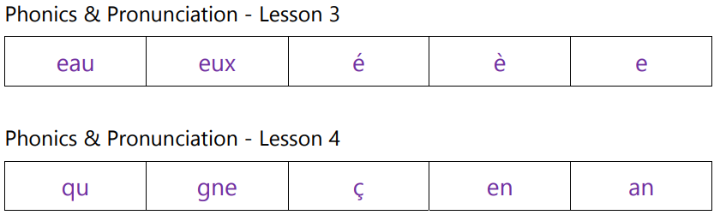

Autumn - La date (The date)
Days of the week, months of the year and numbers 1-31 will be introduced, revised and consolidated so, by the end of this unit, pupils will have the knowledge and skills to say the date and when their birthday is in French
Programme of Study
Listening | Speaking | Reading |  | Writing | Grammar
Listen attentively to spoken language  and show understanding by joining in and responding.  Explore the patterns and sounds of language through songs and rhymes and link the spelling, sound and meaning of words. | Engage in conversations; ask and  answer questions; express opinions and respond to those of others; seek clarification and help.  Speak in sentences, using familiar vocabulary, phrases and basic language structures.  Develop accurate pronunciation and intonation so that others understand when they are reading aloud or using familiar words and phrases.  Present ideas and information orally to a range of audiences. | Read carefully and show  understanding of words, phrases and simple writing.  Broaden their vocabulary and develop their ability to understand new words that are introduced into familiar written material, including through using a dictionary.  Appreciate stories, songs, poems and rhymes in the language. |  | Write phrases from memory, and  adapt these to create new sentences, to express ideas clearly. | Understand basic grammar  appropriate to the language being studied, including (where relevant): feminine, masculine and neuter forms and the conjugation of high- frequency verbs; key features and patterns of the language; how to apply these, for instance, to build sentences; and how these differ from or are similar to English.
Outcomes  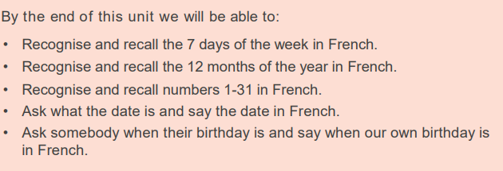 |  |  | Grammar  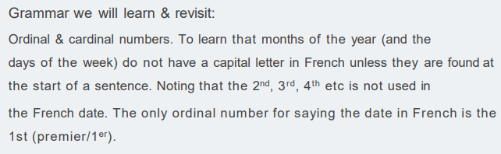

Phonics and Pronunciation  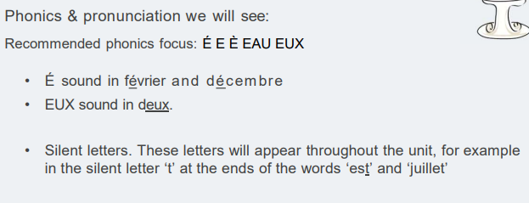 | Vocabulary  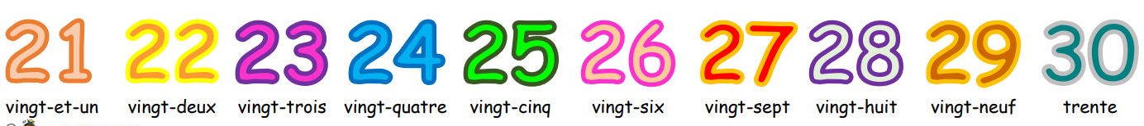  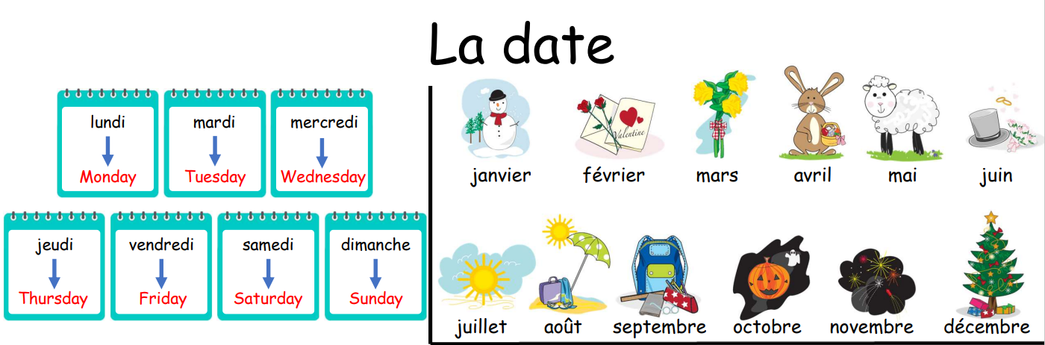  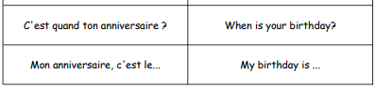  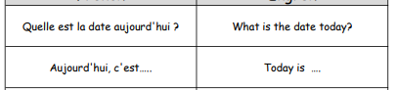

Spring - Quel temps fait-il? (What is The Weather)
By the end of this unit pupils will have the knowledge and skills to describe the weather and to also present a weather forecaster pretending to be on television. This enables us to link the weather vocabulary with map work, compass points and general geography. This unit improves both language and cultural knowledge.
Programme of Study
Listening | Speaking | Reading | Writing | Grammar
Listen attentively to spoken language  and show understanding by joining in and responding.  Explore the patterns and sounds of language through songs and rhymes and link the spelling, sound and meaning of words. | Engage in conversations; ask and  answer questions; express opinions and respond to those of others; seek clarification and help.  Speak in sentences, using familiar vocabulary, phrases and basic language structures.  Develop accurate pronunciation and intonation so that others understand when they are reading aloud or using familiar words and phrases.  Present ideas and information orally to a range of audiences. | Read carefully and show  understanding of words, phrases and simple writing.  Appreciate stories, songs, poems and rhymes in the language.  Broaden their vocabulary and develop their ability to understand new words that are introduced into familiar written material, including through using a dictionary | Write phrases from memory, and  adapt these to create new sentences, to express ideas clearly.  Describe people, places, things and actions orally* and in writing. | Understand basic grammar  appropriate to the language being studied, including (where relevant): feminine, masculine and neuter forms and the conjugation of high- frequency verbs; key features and patterns of the language; how to apply these, for instance, to build sentences; and how these differ from or are similar to English.

Outcomes  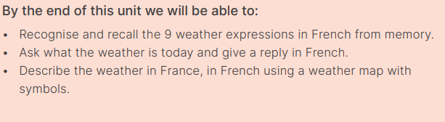 | Grammar  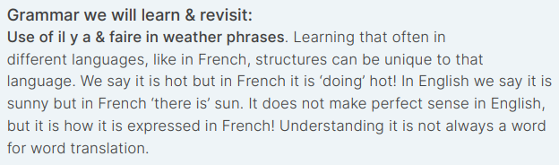
Phonics and Pronunciation  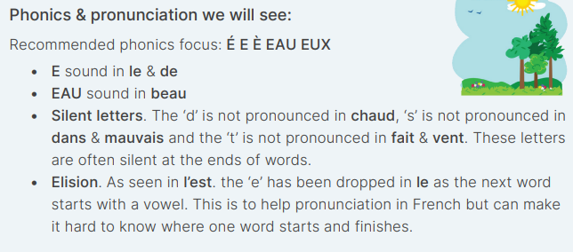 | Vocabulary  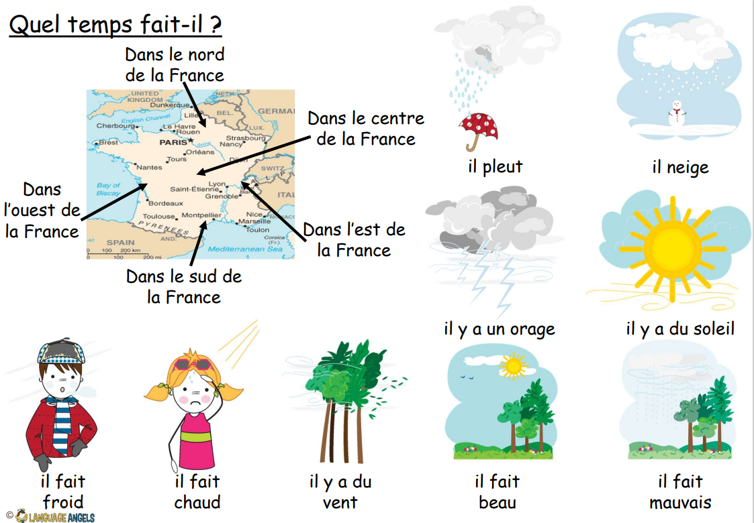  

Summer - A l’ecole (At School)
In this unit pupils will learn the nouns and definite articles/determiners for 10 school subjects in the foreign language. They will also learn how to conjugate the verb “to study”, an introduction to time and an expansion of opinions. By the end of the unit pupils will have the knowledge and skills to talk about the subjects they like and dislike at school (along with a justification) and at what time/day they study various subjects. This will enable pupils to create more detailed and personalised responses by the end of the unit.
Programme of Study
Listening | Speaking | Reading |  | Writing | Grammar
Listen attentively to spoken language  and show understanding by joining in and responding.  Explore the patterns and sounds of language through songs and rhymes and link the spelling, sound and meaning of words. | Engage in conversations; ask and  answer questions; express opinions and respond to those of others; seek clarification and help.  Speak in sentences, using familiar vocabulary, phrases and basic language structures.  Develop accurate pronunciation and intonation so that others understand when they are reading aloud or using familiar words and phrases.  Present ideas and information orally to a range of audiences. | Broaden their vocabulary and develop their ability to understand new words that are introduced into familiar written material, including through using a dictionary.  Appreciate stories, songs, poems and rhymes in the language |  | Write phrases from memory, and  adapt these to create new sentences, to express ideas clearly.  Describe people, places, things and actions orally* and in writing | Understand basic grammar  appropriate to the language being studied, including (where relevant): feminine, masculine and neuter forms and the conjugation of high- frequency verbs; key features and patterns of the language; how to apply these, for instance, to build  sentences; and how these differ from  or are similar to English.
Outcomes  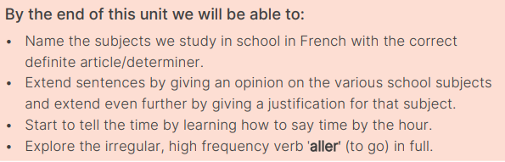 |  |  | Grammar  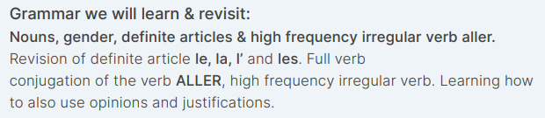
Phonics and Pronunciation Phonics  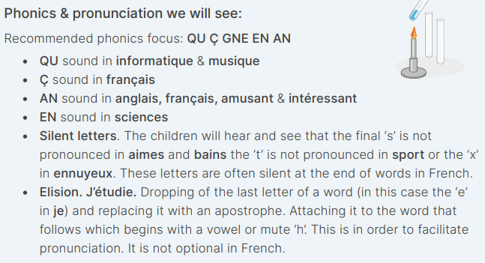  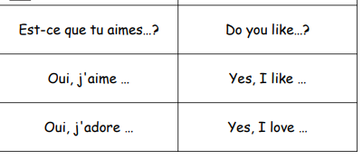 |  |  | Vocabulary  