

Graduated Response and Adaptations Document
Cardinham School
February 2026
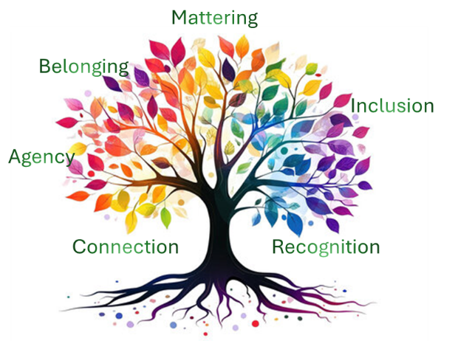

TPAT is driven to create a sense of belonging and mattering within our school communities and to create learning environments where all pupils, regardless of their individual differences or needs, feel valued, respected, supported and are facilitated to participate fully in their learning experiences.

Our commitment goes beyond including pupils with disabilities and encompasses all forms of diversity, including those with different learning preferences, cultural backgrounds, socioeconomic statuses and lived experiences.

Visual Adaptations within books and on iPads

Supporting pupils doesn’t mean creating entirely separate lessons; it means designing learning that is accessible, ambitious, and flexible. With increased level of need then often increased levels of adaptations will be needed.





2. Adapted Work & Planning

Clear evidence includes:
- Sentence stems
- Adjusted reading texts glued in
- Scaffolded worksheets
- Word mats or vocabulary banks
- Reduced writing demands (e.g., 3 sentences instead of a full paragraph)
- Maths with models, images, concrete examples drawn or stuck in.
- Shortened tasks to meet need of learner.
Greater adaptations:
- Alternative tasks which achieve the same outcome.
- Individualised adapted tasks and objectives.
- Replacement or alternative curriculum activities
1. Adapt Learning Objectives
Keep the same long-term ambition but adjust the route:
1: Same task, different scaffolding (most inclusive).
2: Same objective, adjusted complexity (e.g., use simpler texts or numbers).
3. Different but related objective if achievement gap is significant.
4. Alternative Recording

Evidence looks like:
- Typed work printed and stuck in to books or stored on iPad.
- Speech-to-text pieces with a different font (iPad)
- Photographic record
- Video record of task.
- Voice notes or recording
- Use of mind maps
- Use of Widget to present a response.
- Visual representation (collage etc).
3. Adult Support (Strategic)

You will commonly see:
- Live marking in books
- Written prompts from the adult
- Highlighted instructions
- Model sentences written lightly by an adult for tracing
- Guided examples completed together (We Do).
- Feedback that promotes independence

Greater adaptations:
- Adult scribing
- Fully written sentence frames for completion
- Highly simplified instructions
- Bespoke scaffolded tasks
- Individualised timetables
- Individualised adapted learning objectives

Visual Adaptations within books and on iPads

Supporting pupils doesn’t mean creating entirely separate lessons; it means designing learning that is accessible, ambitious, and flexible. With increased level of need then often increased levels of adaptations will be needed.





8. Sensory adaptations
Although these in themselves are not in the books, you might see:
- Shorter bursts of written work
- Neater work after movement breaks
- Work completed on coloured paper, overlays, or larger lines
- More complete answers (because the child had time)
- Fewer unfinished tasks
- Slower pace across pages but higher accuracy
- Written work starting later on the page after modelling
- Fewer scribbles or emotional outbursts on the page -calm, focused work following regulation breaks
- Tasks completed in short sections with gaps in between
- Behaviour charts or learning check-ins stuck in

7. Visual Supports
You might see:
- A now/next stuck at the top of the page
- Task boards printed into books
- Visual success criteria (e.g., checklists with icons)
- Colour-coded steps for tasks
- Word banks with images

- Adapted Instructions

Books might show:
- Highlighted or underlined key words
- An example model stuck at the top
- A worked example
completed jointly with the teacher
- Sentence starters or writing frames
- Simplified language printed/stuck into the book
- Use of Widget to simplify instructions

6. Chunking Tasks
Evidence may include:
- Tasks broken into numbered steps
- Boxes separating sections of work
- Mini-tasks with tick boxes
- Checkpoints (“Step 1 complete ✔️”)
- Shorter, scaffolded tasks instead of long, open-ended ones

Communication & Language

 | Wave 1 (Universal) Provision | Wave 2a Provision | Wave 2b Provision | Wave 3 Provision
C&I | - Clear objectives  - Success criteria  - Teacher modelling  - Cold calling  - Think, pair, share,  - Show me board  - Visual timetables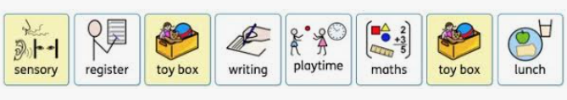  - Now & Next -  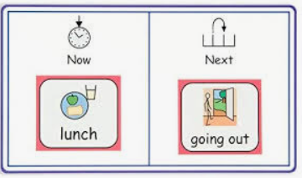  - Simplified instructions  - Thinking time  - Check understanding  - Vocab pre-teach  - Speech sound modelling  (Do NOT ask them to repeat it.  YOU say it back correctly in a natural sentence.)    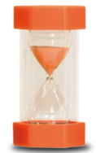  - Timers(spot/sand)  - ShREC approach (EYFS) – Share attention, Respond, Expand, Conversation  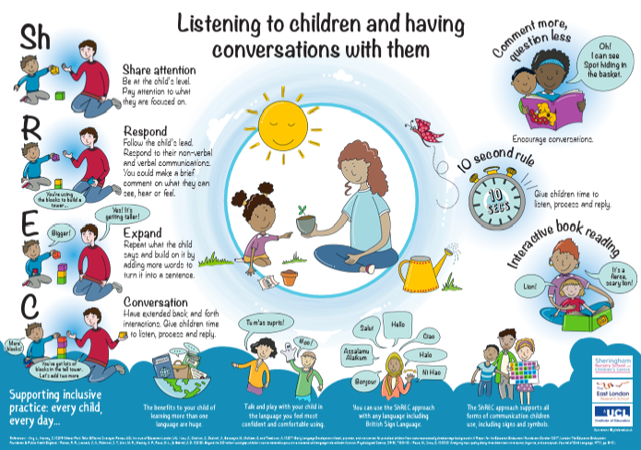  - Signalled transitions from one task to another. | - Chunking information and tasks into smaller steps.  - Instruction strips   - Writing support board  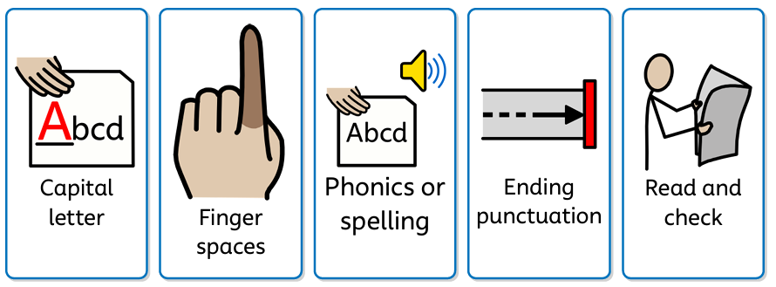  - Now and next boards (independent)  - WELLCOMM screener targets (or similar)  - 1:1 or small-group speech sound work  - Vocabulary sessions (inc. pre teaching)  - Cue cards  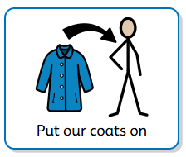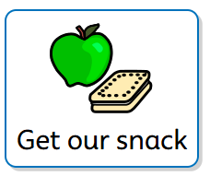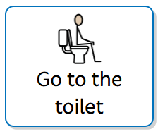  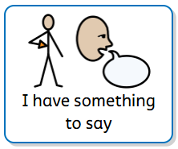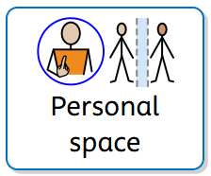  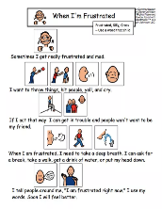  - Social stories  - Transition support  - Timers (Individual sand)  - Zones of regulation / 5-point scale  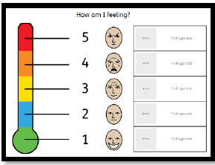  - Word mat  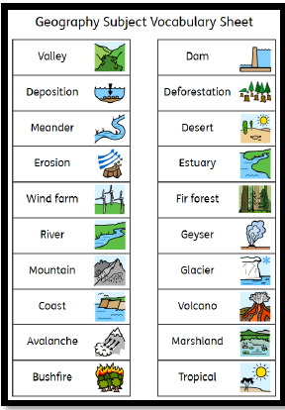 | - Consider SENCo-led referral to Communication team  - Consider SENCo-led referral to Speech and Language Team  - Consider SENCo-led ND profiling Tool  - Consider SENCo-led SALT referral  - Specialist SLCN programmes  - Speech sound intervention with review  - Structured vocabulary programmes  - Formal attention & listening sessions. | - SALT input and plan  - Alternative communication (objects of reference)  - Sign-supported communication, AAC)  - Intensive Interaction and modelling of language structures.  - Individually tailored visuals and communication systems.  - Social communication groups  - Specialist support for communication and social understanding.
  Original
  “First, look carefully at the picture and think about what is happening. Then answer the question using a full sentence. Remember to check your work to make sure it makes sense before moving on to the next task.”
  Simplified
  1. Look at the picture
  2. Think about what is happening
  3. Say your answer
  4. Check it makes sense” 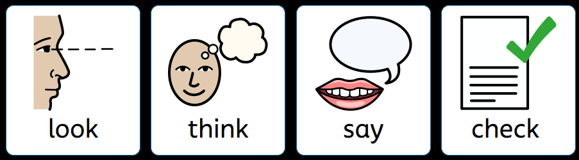
  Child is upset after a disagreement.
  Adult kneels beside and uses calm voice:
  - “I can see you’re feeling cross.”
  - “It’s okay to feel cross, but it’s not okay to shout at people.”
  - “Let’s take 3 breaths together.”
  - “When you’re ready, we can sort the problem.”

Social Communication

 | Wave 1 (Universal) Provision | Wave 2a Provision | Wave 2b Provision | Wave 3 Provision
SC | - Emotion coaching / provide social scripts  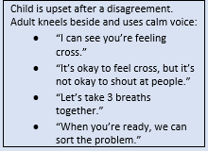  - Year 6 transition support MHST (children and parents)  - Predictable routines  - Visual timetables  - Transitions warnings (on visual timetable, social story)  - Signpost to Silvercloud  - Roles/responsibilities -  Eco/sport/learning champions, classroom monitors  - Restorative conversations  - Safe space  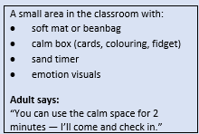 | - 1:1 or small-group social skills  - Social stories  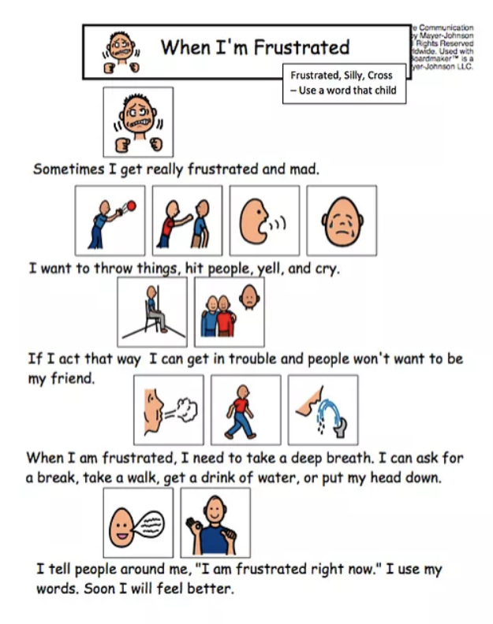  - Adult-supported transitions  - Structured group modelling  - Adapted play/lunch  - Break-out space  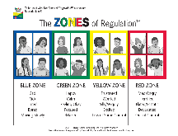  - Zones of regulation / 5-point scale  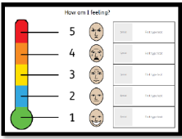  - Makaton (if appropriate) | - Consider SENCo-led ND profiling tool  - Consider SENCo-led liaison/referral with EP/ASD outreach  - Specialist social communication programmes  - Social stories written with SENCo  - Structured play/social coaching.  - Personalised timetables  - Comic book scenarios  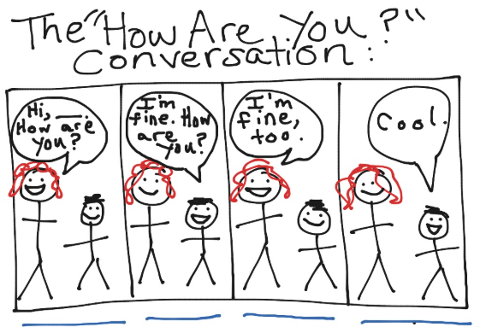  - Personalised workspace  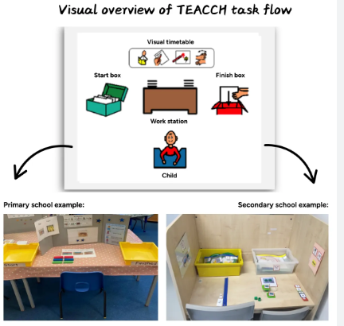 | - 1:1 specialist support in class  - 1:1 support at breaks and transitions  - Personalised learning schedule  - Specialist social communication plans.
  Example:
  After a conflict between children:
  - “What happened?”
  - “How were you feeling at the time?”
  - “How do you think the other person felt?”
  - “What needs to happen now to fix the situation?”
  End with a short agreed action:
  - “Let’s play together for 5 minutes and start again.”

Cognition & Learning

 | Wave 1 (Universal) Provision | Wave 2a Provision | Wave 2b Provision | Wave 3 Provision
C&L | - Clear objectives  - Success criteria  - Live feedback  - Modelling  - Cold calling  - Think, pair, share,  - Show me board  - Regular retrieval practice  - Extra processing time  - Low arousal environment (silent / quiet working)  - AfL/adaptive teaching - do children need visual supports/manipulatives/ work with a partner/challenge question  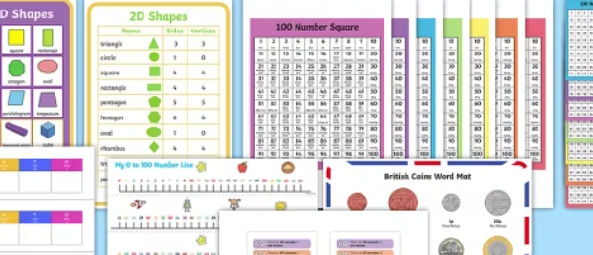  Adapt to fit school interventions  - Read Write inc. phonics  - Guided reading group  - Mastering Number  - Maths.co.uk  - Times Table Rockstars  - Illustrated Dictionaries  - Chunked instructions/simple language (can you add visuals?)  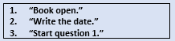  - Frequent review – hinge questions  - Multisensory teaching (two or more senses working together – e.g. manipulatives, acting it out)  - Seating for positive models  - Cognition and learning Dyslexia awareness assembly  - Coloured overlays (screen filter on iPad)   | - Task boards  - Chunking of tasks into smaller steps.  - Dual coding (e.g. word mat, instruction/behaviour strip)  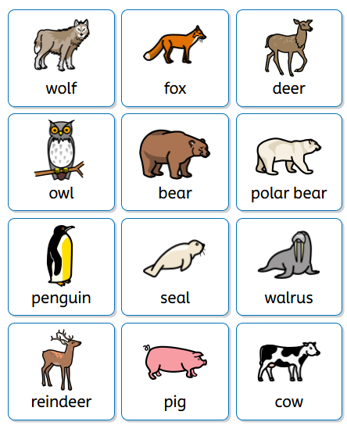  - Small-group adult support  - Pre-teach/catch-up / overlearning  - 1:1/small group boosters  - Scaffolded tasks  - Foundational skills assessment (or other assessment)  - Writing / Spelling Frame  - Phonics Catch Up  - Precision Teaching  - Literacy Gold  - Mastering Number  - Assistive technology (speech to text)  - Larger lines / squares to record onto  - Individual readers  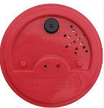  - Working memory supports – e.g. 3/4-step visuals/talking tins  - Use of iPads with Showbie to enable pupils to refer back to PowerPoint slides (recap / task board / instructions).  - Use of iPads with Showbie to enable pupils to refer back to pre-filmed videos of explicit teacher instruction | - Consider SENCo-led ND Profiling Tool  - Consider SENCo-led Cognition and learning/EP referral  - Screening tools (e.g. DST-J) used to identify barriers & set personalised targets  - Precision teaching  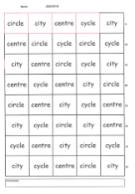  - Touch Typing programme – e.g. Dance Mat  - Specific, targeted, timed intervention for SPAG/Maths/handwriting/  sentence formation or other area.  Ie Rapid writing, Project X CODE, colourful semantics, Nessy spelling, Numicon, Numberstacks etc. | - Cognition and Learning/EP specialist input  - Personalised learning schedule  - Reduced timetable (multi-agency)  - Curriculum adaptations from specialist assessments.  - Technology-led learning support (specialised apps, dictation software)

Social, Emotional & Mental Health

 | Wave 1 (Universal) Provision | Wave 2a Provision | Wave 2b Provision | Wave 3 Provision
SEMH | - Whole School Positive Behaviour Reward System (add own system).  - Whole School and Class Rules  - Emotion coaching and adult emotional check ins and co-regulation.  - PSHE lessons and assemblies  - Circle Time (EYFS)  - Consistent routines  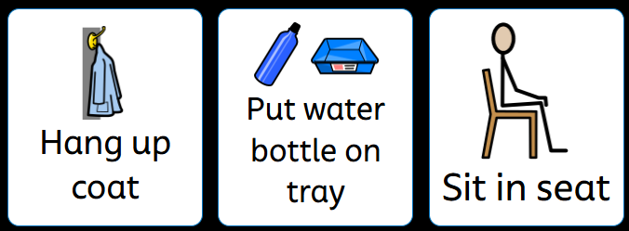  - Low arousal classroom and safe spaces  - Calm/supported/relational start and end to the day  - Whole class movement breaks  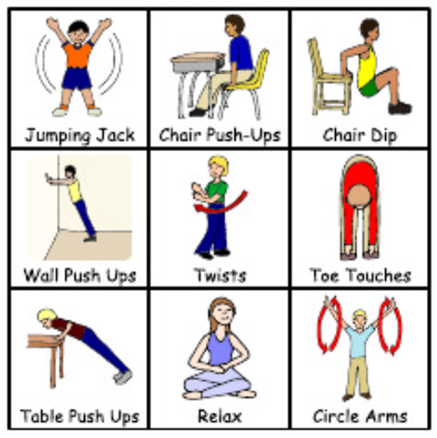  - Co-regulation  - Restorative practices;  - Roles/responsibilities -  Eco/sport/learning champions, classroom monitors  - Use of Breathing Techniques  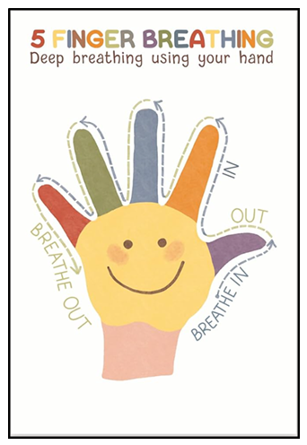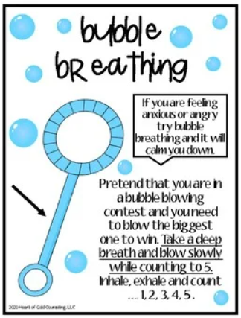  - Adapted play/lunch | - 1:1 check-ins  - Increased home-school links  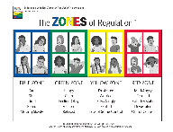  - SENCo 1:1/Small-group nurture/therapeutic MHST/ELSA (child/parent)  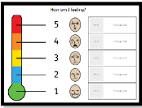  - Personalised Zones of regulation/5-point scale  - Decompression end-of-day routine  - Break-out space  - Individualised movement breaks  - Signpost to Silvercloud  - Use of timers (spot / sand / visual) | - Consider SENCo-led ND Profiling Tool  - Consider SENCo-led referral to Nurture/therapeutic groups MHST (child/parent)  - Consider SENCo-led referrals to EP/Bloom/CAMHS  - Consider SENCo-led referral to Early Help  - Personalised regulation plans  - Home/school diary  - Anxiety/self-regulation programmes (child/parent)  - Personalised, daily ‘Into school’ routines – soft start.  - Personalised, daily ‘leaving school’ routines – soft close. | - CAMHS involvement  - 1:1 specialist support  - Multi-agency SEMH plan  - Personalised specialist regulation tools  - Individualised behaviour support plan.  - Behaviour interventions
  A small area in the classroom with:
  - soft mat or beanbag
  - calm box (cards, colouring, fidget)
  - sand timer
  - emotion visuals
  Adult says:
  “You can use the calm space for 2 minutes — I’ll come and check in.”
  Examples:
  - meet-and-greet at door
  - first 5 minutes in a quiet area with a trusted adult
  - simple low-demand tasks (Lego, sketching, whiteboard doodle)
  - morning visual timetable already displayed
  Example:
  - Child starts to escalate.
  Adult stays close and models regulation:
  - slow breathing
  - soft tone
  - grounding: “Feet on the floor, hands still.”
  - “You can borrow my calm.”
  - “Let’s breathe together… in… out…”
  Example:
  After a conflict between children:
  - “What happened?”
  - “How were you feeling at the time?”
  - “How do you think the other person felt?”
  - “What needs to happen now to fix the situation?”
  End with a short agreed action:
  - “Let’s play together for 5 minutes and start again.”
  - Move to quiet spot (1 minute)
  A small, low‑stim area with soft voices and
  predictable steps.
  - Choose 1 calm activity (3–5 minutes)
  Colouring/doodling, Small Lego, Sensory
  tools (tangle, stress ball), Quiet book, Simple
  puzzle
  - Regulation reset (1 minute)
  Deep breaths, 5‑finger breathing, Stretch /
  wall push‑ups
  - Check‑out (30 seconds)
  Emoji/Zones card. Thumbs up/side/down
  - Supported dismissal (1–2 minutes)
  Adult quietly summarises the plan for home
  /next day: “You’ve had a calm finish.
  Tomorrow starts with __. See you then.”

Physical & Sensory

 | Wave 1 (Universal) Provision | Wave 2a Provision | Wave 2b Provision | Wave 3 Provision
P&S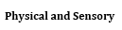 | - Low arousal environments  - Carefully considered seating plans.  - Individual work spaces / working environment (standing to write etc).  - Movement breaks  - Universal sensory circuit  - Pen/Pencil choices      - Ear defenders  - Considered seating  - Techniques/Strategies to aid with Visual Perception e.g. use of highlighters, darkening lines.  - Adapted play/lunch. | - Sensory audit and diet  - Targeted sensory strategies  - Personalised equipment  - Soft start - personalised  - Wobble cushions      - Fidget tools (school may provide to prevent inappropriate tools e.g. Tekdeks)  - Sensory tools – fidget tools, chewellery, chair bands, theraputty)  - Adaptive tools (pen grips, easi Grip scissors, sloped boards  - Uniform adaptations  - Gross/fine motor intervention  - MOVES or Funfit  - Sensory circuits  - Decompression end-of-day routine  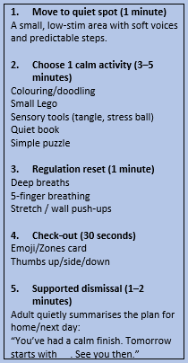 | - Consider DSDQ screener  - Consider SENCo-led ND Profiling Tool  - Consider SENCo-led referral to OT  - Sensory diet with SENCo/OT  - Additional sensory breaks; OT equipment  - Personalised workspace | - OT input/plan  - Physio input/plan  - 1:1 support for PE  - Adaptive technology  - Medical team involvement  - Personalised sensory diet  - Specialist medical care plans.

Graduated Response Cycle

