

Mathematics Calculation Policy

Cardinham School

Introduction
This policy aims to develop, model and explain core understandings and mathematical principles and progression to ensure consistency in the teaching and learning of mathematics in our schools.
The focus of this policy is the calculation of the four mathematical operations with an emphasis on written strategies to clarify processes and understanding and to make direct links to mental calculating. It is crucial that these mental strategies are discretely taught and linked to written strategies and not confined to starter activities in lessons.
The overall aims of this policy are that, when children leave primary school they:
- have a secure knowledge of number facts and a good understanding of the four operations supported by a fluency and understanding of the fundamentals of mathematics

- includes the idea of variation theory which is linked to mastery and has been adapted following the joint England Shanghai maths project of 2014/15 which the school was a part of. This is taking known facts and repeating these to support the application of skills.
- know the best strategy to use, estimate before calculating, systematically break problems down into a series of simpler steps with perseverance and use estimation and rounding to check that an answer is reasonable

- are able to use this knowledge and understanding to carry out calculations mentally, solve problems of increasing complexity and develop an ability to recall and apply knowledge rapidly.
- make use of diagrams and informal notes and jottings to help record steps and partial answers when using mental methods
- have an efficient, reliable, compact written method of calculation for each operation, which they can apply with confidence when undertaking calculations

- be able to identify when a calculator is the best tool for the task and use this primarily as a way of checking rather than simply a way of calculating.

- be able to explain their strategies to calculate and, using spoken language, give mathematical justification, argument or proof.

Year 1 – addition
Curriculum 2014 Statutory Requirements
Pupils should be taught to:
 read, write and interpret mathematical statements involving addition (+) and equals (=) signs – THIS MEANS THE SAME AS – relate this to balance number sentences and scales
 represent and use number bonds and related subtraction facts within 20
 add one-digit and two-digit numbers to 20, including zero
 solve one-step problems that involve addition, using concrete objects and pictorial representations, and missing number problems such as 9 = □ + 7.
Using a marked number line with marked divisions to 20 to solve calculations such as:  9 + 7 = □ Demonstrate with frogs jumping along the line  Number tracks  Appropriateness of number: choices of number here remain within 20 and build towards crossing 10.  Progress – numbered line, divisions with numbers on.  Begin to introduce □ = 9 + 7 to show the symbolism of balanced calculations and commutative number sentences.  Working up from number bonds to 5,6,7,10, 20.  Practical equipment to support this addition work: Coat hangers, bead strings, 100 squares, Concrete objects, magic beans, numicon, base ten materials  Use part + part = whole as variation | Teaching Points  Numbers to 20  Counting forward/up in jumps on top of the number line when adding.  Model the checking process as this is built upon throughout the strategies and policy.  Snakes and ladders game good to support  Ensure that children are being taught to count the jumps.  Variation ideas  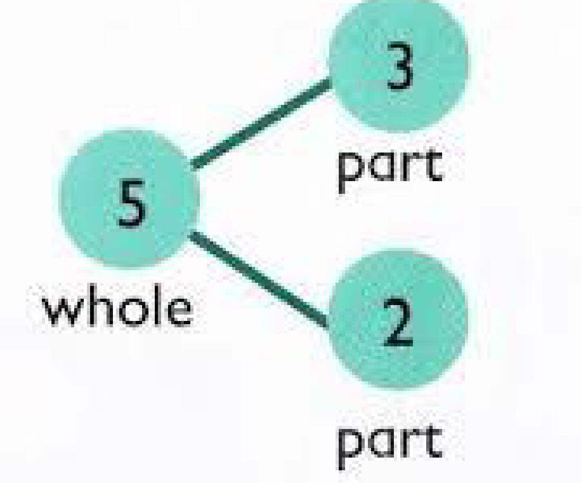  7 + 2 =  17 + 2=  7 + 12 =  9 + 6 =  10 + 6 =  11 + 6 =  13 + 6 =  8 + 3 =  10 + 3 =  12 + 3 =
  9 | 10 | 11 | 12 | 13 | 14 | 15 | 16 | 17 | 18

Year 2 – addition
Curriculum 2014 Statutory Requirements
Pupils should be taught to:
 solve problems with addition:
 using concrete objects and pictorial representations, including those involving numbers, quantities and measures
 applying their increasing knowledge of mental and written methods
 recall and use addition facts to 20 fluently, and derive and use related facts up to 100
 add numbers using concrete objects, pictorial representations, and mentally, including:
 a two-digit number and ones
 a two-digit number and tens
 two two-digit numbers
 adding three one-digit numbers
 show that addition of two numbers can be done in any order (commutative) and subtraction of one number from another cannot
 recognise and use the inverse relationship between addition and subtraction and use this to check calculations and solve missing number problems
Once understanding of place value is secure using practical resources eg) base ten, bead strings, numicon etc, children will move to ‘petal method’ for adding two, two digit numbers.  Partitioning and applying addition mentally of partitioned numbers:  40 + 30 = 70  47  36  + = 83  7 + 6 = 13  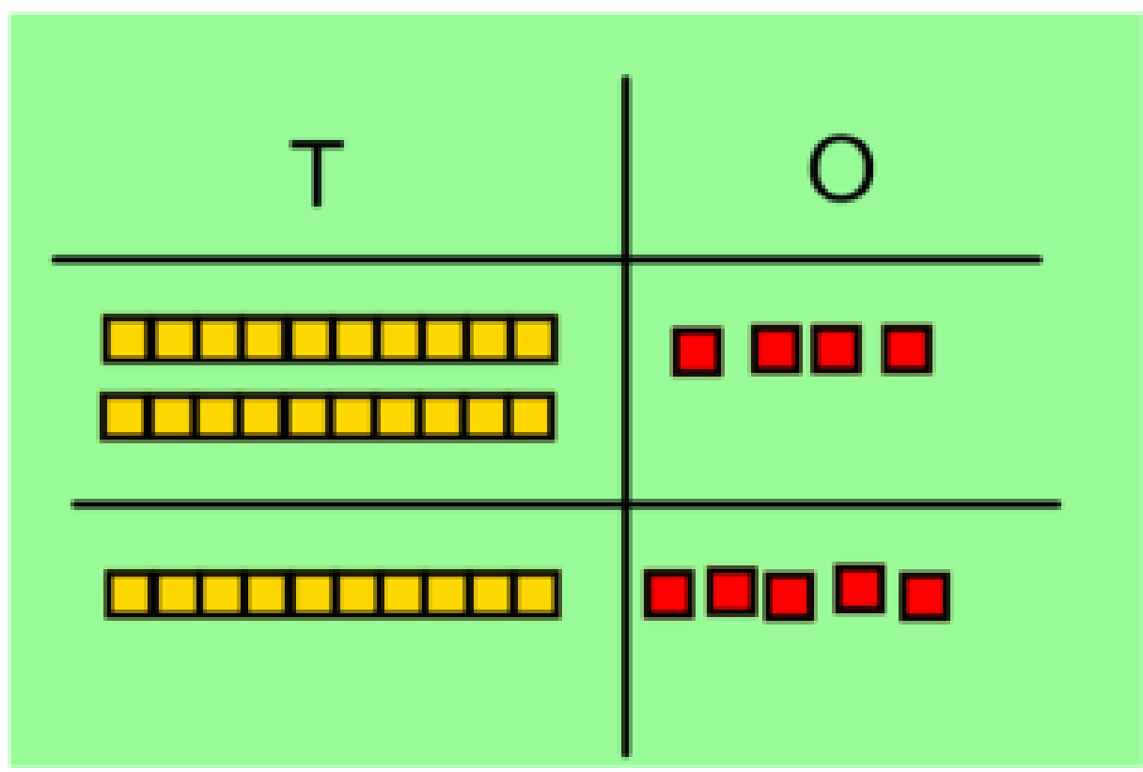  Progressing to expanded written, column method:  Start with no crossing of tens, then  onto crossing tens at the end of the  year .  Ensure that the calculation done at  each stage is written beside so children  are aware of process. | Teaching Points  Counting forward in ones then tens. When counting in ones, suggesting ‘number bonds’ and related facts to make jumps.  Headings of columns for addition are labelled  Note how appropriateness of number ensures that these numbers do not require carrying at this stage.  Variation ideas  8 + 2 = 10  80 + 20 =100  800 + 200 = 1000  ? = 8 + 2  10 = ? + 2  100 = ? + 20
   | T | O
   | 4 | 7
  + | 3 | 6  (7+6)  (40+30)
   | 1 | 3
   | 7 | 0
   | 8 | 3

Year 3 – addition
Curriculum 2014 Statutory Requirements
Pupils should be taught to:
 add numbers mentally, including:
 a three-digit number and ones
 a three-digit number and tens
 a three-digit number and hundreds
 add numbers with up to three digits, using formal written methods of columnar addition
 estimate the answer to a calculation and use inverse operations to check answers
 solve problems, including missing number problems, using number facts, place value, and more complex addition.
Formal written strategy modelled with:  H T O labelled in columns.  One digit per square.  Calculate from ones (least significant figure).  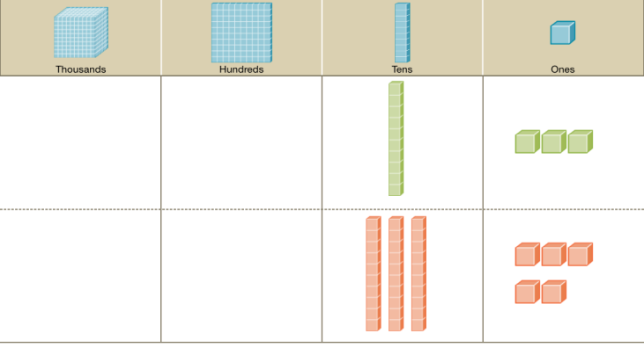  Base ten materials used to support addition process  Eg)  + 13  35  8  40  48 | Teaching Points  Numbers initially crossing tens boundary within a three digit number, moving to crossing tens and hundreds in numbers up to 1000.  Pupils begin to use number lines without given divisions.  Teaching point in example links to recognising number bonds and how smaller jumps, rather than jumping eight will help reinforce mental strategies.  Variation:  Missing numbers
   | H | T | O
   | 2 | 7 | 8
  + |  | 8 | 2
   |  | 1 | 0
   | 1 | 5 | 0
   | 2 | 0 | 0
   | 3 | 6 | 0  Refer to this area as the working space

Year 4 – addition
Curriculum 2014 Statutory Requirements
Pupils should be taught to:
 add with up to 4 digits using the formal written methods of columnar addition where appropriate
 estimate and use inverse operations to check answers to a calculation
 solve addition two-step problems in contexts, deciding which operations and methods to use and why.
Formal written strategy modelled with:  Th H T O labelled in columns.  One digit per square.  Calculate from ones (least significant figure). | Teaching Points  Building on strategy from Year 3 moving to using numbers which, when added, remain within the 10,000 boundary.  Ensure clarity when adding two, four digit numbers and move to adding up to three integers including three-digit add four-digit.  Progressing to the use of formal, compact method (modelling alongside expanded method).  Variation ideas
   | Th | H | T | O
   | 4 | 6 | 2 | 7
   | 3 | 9 | 1 | 4
   | 8 | 5 | 4 | 1
   | 1 |  | 1
   | 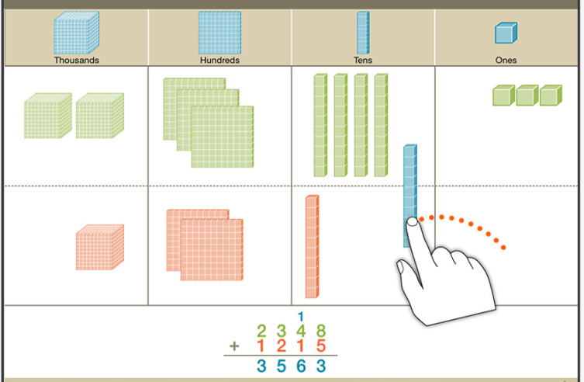 | Base ten materials used to support understanding to abstract.

Year 5 – addition
Curriculum 2014 Statutory Requirements
Pupils should be taught to:
 add whole numbers with more than 4 digits, including using formal written methods (columnar addition)
 add numbers mentally with increasingly large numbers
 use rounding to check answers to calculations and determine, in the context of a problem, levels of accuracy
 solve addition multi-step problems in contexts, deciding which operations and methods to use and why.
Building on Y4 strategy and number choices moving to numbers, when added within 1 million.  Progressing to addition of numbers to two decimal places in context (such as money £ including € and $ as appropriate)  Estimating answers:  Rounding this calculation to nearest ten:  £130 + £210 = £340  £132.52 + £213.83  1/10 1/100  Note appropriateness of number above where there is only one ‘carry’ initially to ensure clarity and understanding of the layout and process. | Teaching Points  Note appropriateness of numbers: initially, when dealing with larger numbers, not requiring ‘carrying’ to ensure clarity and understanding of application of strategy moving swiftly to numbers requiring carrying.  Model when writing the answer, and when writing numbers such as that shown, the use of commas:  96,646  Use of rounding to check the relevance of numbers in answer.  When calculating using numbers involving decimals, a clear step to success must be the writing in of the decimal point in the answer area first to help when carrying past this boundary.  Variation ideas :  37 + 19 = 56  47 + 19 = 66  57 + 19 = 76  5.7 + 1.9 = 7.6
   | TTh | Th | H | T | O
   | 4 | 3 | 2 | 0 | 1
   | 2 | 2 | 1 | 2 | 4
  + | 3 | 1 | 3 | 2 | 1
   | 9 | 6 | 6 | 4 | 6
   | H | T | U |  | t | H
   | 1 | 3 | 2 |  | 5 | 2
  + | 2 | 1 | 3 |  | 8 | 3
   | 3 | 4 | 6 |  | 3 | 5
   |  |  | 1

Year 6 – addition
Curriculum 2014 Statutory Requirements
Pupils should be taught to:
 solve addition multi-step problems in contexts, deciding which operations and methods to use and why
Building on Y5 strategy and number choices moving to numbers, when added within 10 million.  Children secure strategies for addition when adding more than two numbers including numbers to three decimal places.  Calculating decimal numbers to three decimal places: | Teaching Points  Note appropriateness of numbers: initially, when dealing with this size of numbers, not requiring numerous ‘carrying’ to ensure clarity and understanding of application of strategy.  Model when writing the answer, and when writing numbers such as that shown, the use of commas:  678,029 and modelling reading the numbers within the separated groups of numbers.  Reinforce and reiterate the value of each digit when talking about the number.  Note in the example, the use of ‘0’ as a place value holder here and as a digit within the decimal number itself: to reiterate the understanding of its importance and ‘value’.
   | 1 | 2 | 0 | 5 | 3 | 7
   | 2 | 3 | 4 | 2 | 7 | 1
  + | 3 | 2 | 3 | 2 | 2 | 1
   | 6 | 7 | 8 | 0 | 2 | 9
   |  |  | 1 | 1
   | 0 |  | 5 | 5 | 7
   | 1 |  | 2 | 1 | 1
  + | 0 |  | 2 | 0 | 2
   | 1 |  | 9 | 7  1 | 0

Year 1 – subtraction
Curriculum 2014 Statutory Requirements
Pupils should be taught to:
 read, write and interpret mathematical statements involving subtraction (-) and equals (=) signs
 represent and use number bonds and related subtraction facts within 20
 subtract one-digit and two-digit numbers to 20, including zero
 solve one-step problems that involve subtraction, using concrete objects and pictorial representations, and missing number problems such as 9 = □ - 7.
Sam spent 7p. What was his change from 20p?  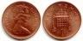  Children use concrete, practical resources moving to images and physically ‘cross off’ or remove to ensure a real understanding of ‘taking away’.  Pupils begin to explore missing number problems involving – and = notation.  7 - 3 = = 7 - 3  7 - = 4 4 = - 3  - 3 = 4 4 = 7 -  - ∇ = 4 4 = - ∇  Solving a problem such as: 19 – 7 =  Counting back from original number on a numberline:  End of year - using counting on to find the difference.  1 2 3 4 5 6 7 8 9 10 11 12 | Teaching Points  When counting the remaining amount, and when checking that the correct number have been taken away, model efficient counting in twos where necessary or arrayed numbers of ten for example.  Model the checking process as this is built upon throughout the strategies and policy.  When solving missing number problems, ensure that there is a variety of layout where there is a modelling of ‘balancing calculations.  Counting back along the top of the number line.  Variation ideas  9 -5 = 9 – 7 =  8 – 5 = 10 – 7 =  7 – 5 = 11 – 7
Year 2 – subtraction
Curriculum 2014 Statutory Requirements
Pupils should be taught to:
 solve problems with subtraction:
 using concrete objects and pictorial representations, including those involving numbers, quantities and measures
 applying their increasing knowledge of mental and written methods
 recall and use subtraction facts to 20 fluently, and derive and use related facts up to 100
 subtract numbers using concrete objects, pictorial representations, and mentally, including:
 a two-digit number and ones
 a two-digit number and tens
 two two-digit numbers
 subtracting three one-digit numbers
 show that addition of two numbers can be done in any order (commutative) and subtraction of one number from another cannot
 recognise and use the inverse relationship between addition and subtraction and use this to check calculations and solve missing number problems
Building on strategies from Y1: using a number line to ‘take away’ and ‘find the difference’ by counting under or on the line respectively.  Start initially with a calculation such as 39 – 7.  Moving to calculations such as: 42 – 5 (crossing tens)  37 40 42  -3 - 2  42 – 27 = 25  +3 +10 +2  27 30 40 42  Model when using the strategy above to find the difference to ‘jump’ to the next ten to help make jumps more straight forward.  Include number puzzles using missing numbers in different forms referring to missing numbers as shapes or letters to build on commutative facts:  70 + 30 = 100 100 - ∆ = 30 30 + □ = 100  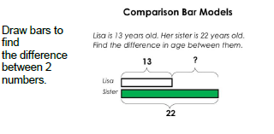 | Teaching Points  This calculation does not cross into the previous tens boundary to ensure clarity on the strategy and ensures understanding through subtracting a ‘ones only’ initially.  Move to modelling counting on top of the line to ‘find the difference’ or under to ‘take away’.  Children use a number line without divisions.  Model breaking down the whole number through partitioning and also, using bonds of numbers such as 2 and 5 = 7 as shown.  Variation ideas  37 – 6 =  47 – 6 =  57 – 6 =  67 – 6 =  77 – 7 =

Year 3 – subtraction
Curriculum 2014 Statutory Requirements
Pupils should be taught to:
 subtract numbers mentally, including:
 a three-digit number and ones
 a three-digit number and tens
 a three-digit number and hundreds
 a three-digit number and thousands
 subtract numbers with up to three digits, using formal written methods of columnar subtraction
 estimate the answer to a calculation and use inverse operations to check answers
 solve problems, including missing number problems, using number facts, place value, and more complex subtraction.
Calculating subtractions from numbers up to 1000.  Model deciding appropriate calculation choices: calculations such as:  296 – 5 or 296 – 35 should be tackled mentally.  As pupils move towards formal, columnar written strategies, begin by modelling the value and layout practically  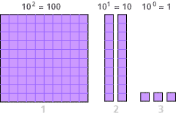  For example, model 346 – 123 using practical resources.  Move to formal columnar strategy using labelled columns and starting with numbers not requiring exchange before strategy and understanding is secure.  H T O  No Exchange at this stage!  - 2 9 8  1 7 9  9 (18 – 9)  1 0 (80 – 70)  1 0 0 (200 – 100) | Teaching Points  Ensure a discrete teaching of mental strategies building upon informal written strategies of number lines and partitioning numbers to subtract tens from tens and ones from ones modelling and promoting the use of jottings.  Note appropriateness of number here where ‘exchanging’ isn’t required.  Practical resources to help promote abstract ‘exchange’ through concrete understanding of place value practically ready for exchanging later in the year.  Modelling practical alongside formal written initially.  Model subtracting from least significant figure (ones).  Remember to use the inverse operation to check
   | H | T | O
   | 3 | 4 | 6
  - | 1 | 2 | 3
   | 2 | 2 | 3

Year 4 – subtraction
Curriculum 2014 Statutory Requirements
Pupils should be taught to:
 subtract with up to 4 digits using the formal written methods of columnar subtraction where appropriate
 estimate and use inverse operations to check answers to a calculation
 solve subtraction two-step problems in contexts, deciding which operations and methods to use and why.
Pupils calculate subtractions from numbers up to 10,000 and beginning to explore decimals in the context of currency (£).  Pupils use columnar written strategies to calculate building upon that from Year 3. As with Year 3, model layout and move to subtraction with the need for exchange using practical materials initially and progressing from 3-digit subtracting a 3-digit to 4-digit subtracting 3 and 4-digit integers. Take the Year 3 demonstration as the starting point in exchange.  Model exchange practically using physical resources and modelling exchanging a ‘100’ for 10 tens and how this is placed within the ‘tens’ place value column.  Progressively move towards 4-digit subtract 3- and 4-digit where again, only one exchange is needed initially.  1  Progressing to subtraction of numbers to two decimal places in context (such as money £ including € and $ as appropriate)  £213.83 - £183.51 | Teaching Points  Note that when modelling practically, and until secure, only one exchange per calculation is required.  Note at the point of physical exchange that the value of the number remains the same (there is still 346, some are simply exchanged).  Modelling of formal written must, initially, occur alongside the practical examples.  When moving to formal columnar method, ensure a progressive learning sequence where only one exchange is required and move this along when secure.  When modelling formal written calculations, model placing a decimal point in the ‘answer line’ before commencing subtracting from the least significant figure.
   | H  2  1 | T | U
   | 3 | 4 | 6
  - | 1 | 6 | 3
   | 1 | 8 | 3
  H  1  1 | T | U | t | h  Estimating answers:  Rounding this calculation to nearest ten: £210 - £180 = £30
  2 | 1 | 3 | 8 | 3
  1 | 8 | 3 | 5 | 1
  0 | 3 | 0 | 3 | 2

Year 5 – subtraction
Curriculum 2014 Statutory Requirements
Pupils should be taught to:
 subtract whole numbers with more than 4 digits, including using formal written methods (columnar subtraction)
 subtract numbers mentally with increasingly large numbers
 use rounding to check answers to calculations and determine, in the context of a problem, levels of accuracy
 solve subtraction multi-step problems in contexts, deciding which operations and methods to use and why.
Strategies build on those of Year 4 and involve starting numbers of up to 100,000 and progressing to 1,000,000.  Formal Written:  Progressively, and before moving to larger numbers, begin to explore written strategies where ‘2 exchanges’ are needed:  Progressively move to calculations such as:  14,067 – 11,850 =  Mental Strategies:  When modelling and teaching mental strategies, refer to picturing the use of a number line and either counting back or on: ∆ = 12,462 – 2,300  10,162 12,162  -2,000 -300 12,462 | Teaching Points  Discrete teaching of the notion of more than one exchange must be taught discretely, and does exchanging through a 0 as shown. Modelling here how an exchange is needed and is placed alongside a prior exchange.  Modelling and checking against estimates is a key part of the calculation process to ensure an understanding and automatic check of validity.  Note use of , to separate chunks of numbers in ‘number sentences’ but not in columnar strategy.  Note use of symbols and algebraic symbols such as x or y to find missing values.  When modelling mental methods, promote values in red as being jottings.
   | Th  8 | H  1  9 | T  1 | U
   | 7 | 9 | 0 | 6  Estimating answers:  E: 7900 – 2600 = 5300
  - | 2 | 5 | 9 | 8
   | 5 | 3 | 0 | 8

Year 6 – subtraction
Curriculum 2014 Statutory Requirements
Pupils should be taught to:
 solve subtraction multi-step problems in contexts, deciding which operations and methods to use and why
Strategies build on those of Year 5 and involve starting numbers of up to 1,000,000 and progressing to 10,000,000.  Pupils apply their learning of subtraction strategies and combine these with other areas of learning to solve problems such as:  632,465 + (745,676 – 325,534) =  progressing to  8,675,509 – (9,645,253 – 2,867,675) =  Pupils apply written subtraction skills to numbers up to and including three decimal places (3dp). These are presented in contextual situations such as ones of measure.  Calculations and ranges of numbers are applied through worded problems including ones of measure.  Calculations to include examples such as:  12 – 2.736  35.712 – 8.653 | Teaching Points  Model the use of brackets in multi-step problems identifying brackets as the initial step needed and combining this with an additional written strategy.  Refer at these stages, as taught in previous years to estimation recorded as E=.  Here, discrete and modelled teaching of ‘selecting the appropriate strategy’ must be taught.  For this example, counting on mentally, or with jottings referring back to knowledge of number lines would work best.  Here, a formal, columnar subtraction strategy will be more effective.

Year 1 - multiplication
Curriculum 2014 Statutory Requirements
Pupils should be taught to:
 solve one-step problems involving multiplication, by calculating the answer using concrete objects, pictorial representations and arrays with the support of the teacher.
Pupils build on learning in the Foundation Stage and ensure a clear understanding of the concept of doubling before moving.  Using concrete objects, image representations and the use of physical or images of arrays, pupils solve problems such as:  There are three sweets in one bag. How many sweets are in five bags?  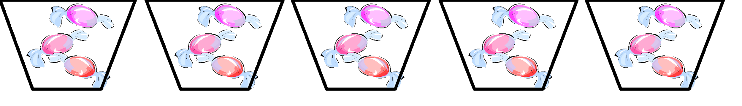    There are three fish in one tank. How many fish are in four tanks?  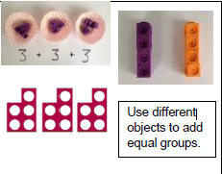  Ensure that pupils experience contextual links such as:  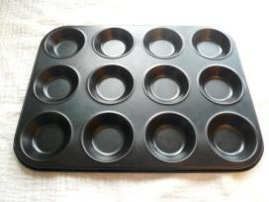 | Teaching Points  Note that when using worded problems, the language aspect of this must be accessible – here, the use of talking tins or image based questioning might be needed to ensure equality of access to the mathematics aspect of the question.  Key vocabulary – Lots of  Make links with repeated addition  Variation Ideas  3 x 2 = 6  2 x 3 = 6  6 = 3 x 2  6 = 2 x 3
  Counting in steps of 2, 5 and 10 – tables progression

Year 2 - multiplication
Curriculum 2014 Statutory Requirements
Pupils should be taught to:
 recall and use multiplication facts for the 2, 5 and 10 multiplication tables, including recognising odd and even numbers
 calculate mathematical statements for multiplication within the multiplication tables and write them using the multiplication (×) and equals (=) signs
 show that multiplication of two numbers can be done in any order (commutative) and division of one number by another cannot
 solve problems involving multiplication and division, using materials, arrays, repeated addition, mental methods, and multiplication and division facts, including problems in contexts.
Pupils recall and use 2x 5x 10x and 3x table but use doubling to progress onto 4x and 6x  Start initially with recap of arrays:  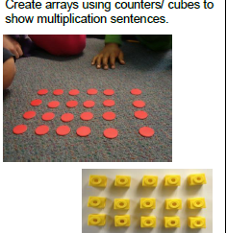  Build on repeated addition  Pupils explore, practically, commutative multiplication facts showing that the same product is produced.  3 x 4 = 12 (3 lots of 4)  Also demonstrate this is the same as 4 x 3   | Teaching Points  Here, build upon partitioning skills to partition and then multiply to strengthen links between place value and partitioning.  Model practically with place value arrow cards to model multiplication steps.  Variation ideas  2 x 3 =  2 x 30 =  2 x 300 =  20 x 3=  200 x 3 =
Year 3 - multiplication
Curriculum 2014 Statutory Requirements
Pupils should be taught to:
 recall and use multiplication facts for the 3, 4 and 8 multiplication tables
 write and calculate mathematical statements for multiplication using the multiplication tables that they know, including for two-digit numbers times one-digit numbers, using mental and progressing to written methods
 solve problems involving missing number problems involving multiplication including positive number scaling problems and correspondence problems where n objects are connected to m objects.
* multiply numbers by 10 and 100 as pre-cursor for grid method*
Pupils recall and use 2x 5x 10x 3x 4x 6x 8x and 9x  Tables knowledge builds on using doubling skills of 2x to find 4x and then doubling 4x to find 8x emphasising efficiency and using known facts.  When first introducing, start with 0-20 - focus on teen numbers before moving on to solve problems such as 34 x 3 using the grid method.  Model calculating this alongside the expanded preparing for short multiplication in Year 4 - teach alongside.  3  X  30 90  4 12  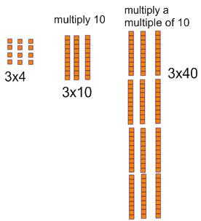  102  When calculating a calculation such as 34 x 2, model and discuss appropriateness of approach and referring to known skills: double. Progress and model to doubling and double again when finding 4x.  Use base ten resources to support | Teaching Points  Use base 10 to support  Note how digits in numbers are, initially, those that are being reinforced and taught through expected multiplication tables knowledge.  Variation ideas  9 x 8 =  9 x 80 =  9 x 800 =  90 x 8 =  900 x 8 =  ? = 900 x 8  72 = ? x 8
Year 4 - multiplication
Curriculum 2014 Statutory Requirements
Pupils should be taught to:
 recall and use multiplication facts for multiplication tables up to 12 x 12
 use place value, known and derived facts to multiply mentally, including: x0 x1 and multiplying together three numbers
 recognise and use factor pairs and commutativity in mental calculations
 multiply two-digit and three-digit numbers by a one-digit number using formal written layout
 solve problems involving multiplying, including the distributive law to multiply two-digit numbers by one-digit including positive number scaling problems and correspondence problems where n objects are connected to m objects.
Pupils recall and use tables facts up to 12 x 12  Ensure secure understanding of multiplying by 10 and 100  Building on the strategies from Year 3, pupils move towards multiples of ten based on the known table facts from above such as 30x and 40x.  Calculations are completed progressing from 2-digit x 1-digit to 3-digit (1[] [] x []) x 1-digit.  Calculations continues an ‘expanded’ formal written methods: | Teaching Points  Note here that number choice ensures that columnar addition is supported in this example where ‘carrying’ of numbers is not required for the strategy to work.  Model brackets to show calculation to ensure and check understanding  Where columnar addition is secure, progress to applying carrying here. Pupils reinforce x10 and x100 through conversions of ones of measure in contextual situations.  Variation ideas  6 x 7 =  6 x 70 =  6 x 700 =  60 x 7 =  ? = 600 x 7  0.6 x 7 =  0.6 x 70 =
  H | T | O
  1 | 4 | 3
   | X | 6
   | 1 | 8 | (3 x 6)
  2  6 | 4  0 | 0  0 | (40 x 6)  (100 x 6)
  8 | 5 | 8
Year 5 – multiplication
Curriculum 2014 Statutory Requirements
Pupils should be taught to:
 identify multiples and factors: all factor pairs of a number, common factors of two numbers, establish whether a number up to 100 is prime and recall prime numbers up to 19
 multiply numbers up to four digits by a one- or two-digit number using a formal written method
 multiply whole numbers and those involving decimals by 10, 100 and 1000.
Autumn Term – Introduce short multiplication  Progress on to 2 x 2 in Spring Term  Using an expanded, columnar multiplication strategy, pupils multiply numbers such as:  37 x 29 | Teaching Points  Note here that this strategy and number choices rely on an ability to use columnar addition efficiently and accurately. Those pupils needing support here can revert to grid but progress to expanded formal as soon as is practicably possible.  Note modelling of noting steps to help with self-checking and ensuring knowledge of place value.  Multiply by ones, explain when multiplying by tens, the numbers will be 10 times bigger, digits move to the left on one place as a result. 0 is a place holder.
  H | T | 0
  1 | 4 | 3
  x |  | 6
  8 | 5 | 8
  2 | 1
   |  | T | O
   |  | 3 | 7
   | X | 2 | 9
   |  | 6 | 3 | (9x7)
   | 2 | 7 | 0 | (9x30)
   | 1 | 4 | 0 | (20x7)
   | 6 | 0 | 0 | (20x30)
  1 | 0  1 | 7 | 3

Year 6 – multiplication
Curriculum 2014 Statutory Requirements
Pupils should be taught to:
 identify multi-digit numbers up to 4 digits by a two-digit number using formal, long multiplication
 identify common factors, common multiples and common prime numbers
 use their knowledge of the order of operations to carry out calculations involving the four operations
Autumn Term – recap short multiplication from Y5  2 3 1 4 x 2 3 =  Pupils progress towards multiplying Th H T U x T U  and H T U . t h x T using formal written method of long multiplication:  36.2 x 7 =  T O 1/10  Progress to three-digit x 2-digit and TU.t x U using expanded formal. Move to Year 6 strategy where these numbers are confident. | Teaching Points  Build here from ‘teens’ to 20s and reinforce efficiency where this number could apply x10 and doubling knowledge.  Variation  Be aware of how calculation maybe in different order. Progress onto missing numbers in the calculation.
  H | T | 0
  1 | 4 | 3
  x |  | 6
  8 | 5 | 8
  2 | 1
   | 2 | 3 | 1 | 4
   | X |  | 2 | 3
   | 6 | 9 | 4  1 | 2
  4 | 6 | 2 | 8 | 0
  5  1 | 3  1 | 2  1 | 2 | 2
   | 3 | 6 |  | 2
  x |  | 7
   |  | 1 |  | 4
   | 4 | 2 |  | 0
  2 | 1 | 0 |  | 0
  2 | 5 | 3 |  | 4
   | 2 | 3 | 1 | 4
   | X |  | 2 | 3
  4 | 6 | 2 | 8 | 0
   | 6 | 9 | 4 | 2
  5  1 | 3  1 | 2  1 | 2 | 2

Year 1 – division
Curriculum 2014 Statutory Requirements
Pupils should be taught to:
 solve one-step problems involving division, by calculating the answer using concrete objects, pictorial representations and arrays with the support of the teacher.

Pupils begin by reinforcing prior learning where division is understood by grouping and sharing:  Develop halving understanding of shapes and numbers initially and move on to quarters.  12 girls play a game in groups of 4. How many are in each group?    Pupils begin to explore related division facts and linking these directly to inverse, commutative facts:  6 ÷ 2 = = 6 ÷ 2  6 ÷ = 3 3 = 6 ÷  ÷ 2 = 3 3 = ÷ 2  ÷ ∇ = 3 3 = ÷ ∇  Sharing in groups of’ begins to be modelled physically on a number line:  8 ÷ 2 = “How many groups of 2 can you take from 8?” | Teaching Points  Children physically group items and count in groups.  Model forming arrays to be organised and systematic to aid counting when this develops into counting in multiples.  Groups of  Shared/Divided in to  Use of a numbered number line and counting jumps and ‘chunks’ of 2 to begin to introduce chunking on a number line.  Repeated subtraction

Year 2 – division
Curriculum 2014 Statutory Requirements
Pupils should be taught to:
 recall and use multiplication and division facts for the 2, 3, 5 and 10 multiplication tables, including recognising odd and even numbers
 calculate mathematical statements for division within the multiplication tables and write them using the signs ÷ and =
 show that multiplication of two numbers is commutative but division is not
 solve problems involving division using materials, arrays, repeated addition, mental methods and division facts, including problems in contexts.
Calculations here build on expected known multiplication facts where division is by a divisor or 2, 5 and 10 initially progressing to Y3 multiplication facts of 3.  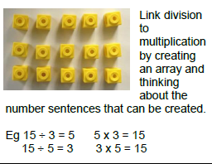  Pupils continue to explore division as sharing and grouping:  18 ÷ 3 can be modelled as sharing – 18 shared between 3 or modelling jumping back in threes to share in ‘chunks’ of 3:  0 3 6 9 12 15 18  Move on to grouping - How many 3’s make 18? Repeated subtraction  0 3 6 9 12 15 18 | Teaching Points  Variation  2 x 3 = 6  3 x 2 = 6  6 ÷ 3 = 2  6 ÷2 = 3  Model counting jumps ‘chunks’ on number line.  Note the appropriateness of number: these calculations do not leave a remainder and build upon multiplication facts that are expected to be fluent.

Year 3 – division
Curriculum 2014 Statutory Requirements
Pupils should be taught to:
 recall and use multiplication and division facts for the 3, 4 and 8 x tables
 write and calculate mathematical statements for division using the multiplication tables they know, including 2-digit divided by 1-digit using mental and progressing to formal written methods
 solve problems, involving missing number problems, involving division, including positive number scaling problems and correspondence problems where n objects are connected to m objects
*Non statutory division 2 digit by 1 digit
Informal Written Method (Bus Stop Method)  36 ÷ 4 =  Write out 4 x tables:  4, 8, 12, 16, 20, 24, etc  Using the chunking method, pupils begin to divide 2-digit numbers by multiplication facts (one-digit) that are expected to be fluent at this stage progressing to any single digit divisor.  Progress on to division with remainders:  4  8  12  16  20  53 ÷ 4 =  Children need to be reminded to always check their answers with the inverse | Teaching Points  Teacher models the layout of a calculation where there are the following key features:  First ten tables facts to build on recall and also, to promote a habit to be referred to later on in the progressive division strategies.  Chunks noted in brackets to count up (not the divisor (4) as this can lead to adding this as a chunk).  First key question as a step to success is ‘Can I take a chunk of 10x?’  Appropriateness of number: these numbers do not need an exchange in the subtraction element of the strategy.
   |  | 9
  4 | 3 | 6
   | 1 | 3 | r 1
  4 | 5 | 3
  - | 4 | 0 | (10x)
   | 1 | 3
  - | 1 | 2 | (3x)
   |  | 1

Year 4 – division
Curriculum 2014 Statutory Requirements
Pupils should be taught to:
 recall multiplication and division facts up to 12 x 12
 use place value, known and derived facts to divide mentally, including dividing by 1
 solve problems involving dividing a three-digit number by one-digit and number using a formal layout
Ensuring an understanding of the relationship between ÷ and X, pupils build on chunking from Year 3 to use this strategy to divide 3-digit numbers by 1- and 2-digit numbers:  432 ÷ 5 =  5  10  15  20  25  30  35  40  Pupils apply short division strategy to solve questions such as fractions of amounts:  1/8 of 12 etc… | Teaching Points  (Non statutory)  Build here from numbers without a remainder using this strategy progressing to a single digit remainder.  Chunks noted in brackets to count up (not the divisor (4) as this can lead to adding this as a chunk).  First key question as a step to success is ‘Can I take a chunk of 10x, 100x or a multiple of 10x?’ (This will be modelled by teacher by applying using known facts and place value.  Greater depth - Here, remainders can begin to be expressed as a fraction. Here, appropriateness of number enables this to be expressed as a decimal with ease. 2/5 = 0.4
   |  | 8 | 6 | r 2
  5 | 4 | 3 | 2
  - | 4 | 0 | 0 | (80x)
   |  | 3 | 2
  - |  | 3 | 0 | (6x)
   |  |  | 2

Year 5 – division
Curriculum 2014 Statutory Requirements
Pupils should be taught to:
 identify multiples and factors, including finding all factor pairs of a number, common factors of two numbers, know and use the vocabulary of prime numbers and establish whether a number up to 100 is prime
 multiply and divide numbers mentally drawing on known facts
 divide numbers up to 4 digits by a one-digit number using a written method and interpret remainders appropriately for the context
 divide whole numbers and those involving decimals by 10, 100 and 1000.
Pupils develop use of the short division method started in Year 4:  Pupils apply short division strategy to solve questions  such as: 1176 ÷ 6 =  6  12  18  24  30  36  42  48  54  60  Pupils apply this with a remainder  1 9 6 r 3  Then interpret the remainder as a fraction  3/6 then a decimal - 0.5  1 9 6 . 5 | Teaching Points  Always write the times tables down the side to help.  Decide using known facts if there will be a remainder – using the rules of divisibility to support.  Always check with the remainder and include approximations to check answer is correct.  Ensure lots of discussion so children have a secure understanding of the place value.
   | 1 9 6
  6 | 115736
  6 | 115739
  6 | 115739.30

Year 6 – division
Curriculum 2014 Statutory Requirements
Pupils should be taught to:
 divide numbers up to 4 digits by a two-digit number using the formal written method of long division, and interpret remainders as whole number remainders, fractions, or by rounding as appropriate for the context.
 divide numbers up to 4 digits by a two-digit number using the formal written method of short division as appropriate.
Pupils use long division to calculate:  432 ÷ 15 =  This answer can be shown as a quotient (rather than an integer remainder): 28 12/15 = 28 4/5  Write out 15x table - short division  Simplify this method into long division  Short division | Teaching Points  Model selection of an appropriate division format – dependent on size of number, efficient ability to apply larger ‘tables facts’ such as 15x as shown.  Here, depending on understanding of this strategy, pupils can refer this calculation to previously taught ‘chunking’.
   |  | 2  13 . 0 | 8. | 8
  15 | 4 | 3 | 2 | 120

Year 1 – Fractions
Pupils should be taught to:
 Recognise, find and name a half as one of two equal parts of an object, shape or quantity.
 Recognise, find and name a quarter as one of four equal parts of an object, shape or quantity.
Year 2 - Fractions
Pupils should be taught to:
 Recognise, find, name and write fractions , , and of a length, shape, set of objects or quantity
Write simple fractions for example, of 6 = 3 and recognise the equivalence of and .
Year 3 - Fractions
Pupils should be taught to:
 Count up and down in tenths; recognise that tenths arise from dividing an object into 10 equal parts and in dividing one-digit numbers or quantities by 10
 Recognise, find and write fractions of a discrete set of objects: unit fractions and non-unit fractions with small denominators
 Recognise and use fractions as numbers: unit fractions and non-unit fractions with small denominators
Recognise and show, using diagrams, equivalent fractions with small denominators
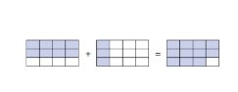
Add and subtract fractions with the same denominator within one whole :
Eg: 8/12 + 3/12 = 11/12 Teaching point – add numerator - ensure children recognise what a whole looks like.
Compare and order unit fractions, and fractions with the same denominators
Year 4 - Fractions
Pupils should be taught to:
 Recognise and show, using diagrams, families of common equivalent fractions
 Count up and down in hundredths; recognise that hundredths arise when dividing an object by one hundred and dividing tenths by ten.
Add and subtract fractions with the same denominator
3/8 + 5/8 = 8/8 same as 1 whole
6/7 – 4/7 = 2/7 Teaching point is subtracting the numerator

Year 5 - Fractions
Pupils should be taught to:
 Compare and order fractions whose denominators are all multiples of the same number
 Identify, name and write equivalent fractions of a given fraction, represented visually, including tenths and hundredths
 Add and subtract fractions with the same denominator and denominators that are multiples of the same number
Add and subtract fractions with the same denominator and denominators that are multiples of the same number
Recognise mixed numbers and improper fractions and convert from one form to the other and write mathematical statements as a mixed number
For example, + = = 1
1/8 + 1/8 = 2/8 = 1/4
¼ + 1/8 = 3/8 – ¼ =2/8 + 1/8 = 3/8
Multiply proper fractions and mixed numbers by whole numbers, supported by materials and diagrams
1/5 x 3 = 3/5
2/5 x 4 = 8/5

Year 6 - Fractions
Pupils should be taught to:
 Use common factors to simplify fractions; use common multiples to express fractions in the same denomination
 Compare and order fractions, including fractions > 1
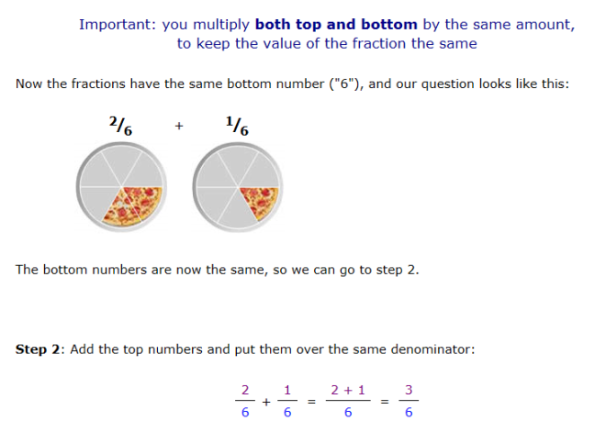
Add and subtract fractions with different denominators and mixed numbers, using the concept of equivalent fractions

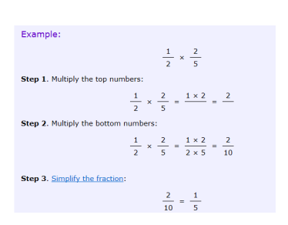
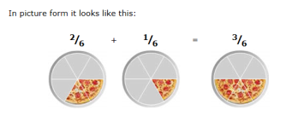
Multiply simple pairs of proper fractions, writing the answer in its simplest form for example, 1/2 x 2/5

Divide proper fractions by whole numbers for example, ÷ 2 =

½ divided by 3 = __1__ = _1_
2 x 3 6
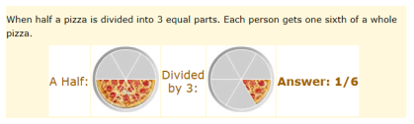

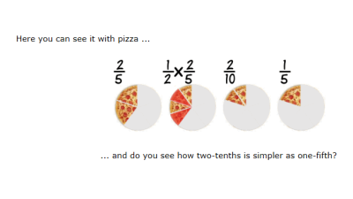

Year 1 – key vocabulary
Words new to Year 1 are in red  Addition and subtraction  +, add, more, plus  make, sum, total  altogether  score  double, near double  one more, two more... ten more  how many more to make...?  how many more is... than...? how much more is...?  -, subtract, take (away), minus leave  how many are left/left over?  how many are gone?  one less, two less, ten less...  how many fewer is... than...? how much less is...?  difference between  half, halve  =, equals, sign, is the same as | Multiplication and division  lots of, groups of  x, times, multiply, multiplied by  once, twice, three times,  four times, five times... ten times...  times as (big, long, wide and so on)  repeated addition  array  row, column  double, halve  share, share equally  one each, two each, three each...  group in pairs, threes... tens  equal groups of  ÷, divide, divided by, divided into, left, left over | Solving problems  Making decisions and reasoning  pattern  puzzle  answer  Odd, even  right, wrong  what could we try next?  how did you work it out?  count out, share out, left, left over  number sentence  sign, operation

- EYFS Vocabulary in black
Year 2 – key vocabulary
Words new to Year 2 are in red  Addition and subtraction  +, add, addition, more, plus  make, sum, total  altogether  score  double, near double  one more, two more... ten more... one hundred more  how many more to make...?  how many more is... than...?  how much more is...?  -, subtract, take away, minus  leave, how many are left/left over?  one less, two less... ten less... one hundred less  how many less is... than...?  how much fewer is...?  difference between  half, halve  =, equals, sign, is the same as  tens boundary | Multiplication and division  lots of, groups of  x, times, multiply, multiplied by  multiple of  once, twice, three times,  four times, five times... ten times...  times as (big, long, wide and so on)  repeated addition  array  row, column  double, halve  share, share equally  one each, two each, three each...  group in pairs, threes... tens  equal groups of  ÷, divide, divided by, divided into, left, left over | Solving problems  Making decisions and reasoning  pattern, puzzle  calculate, calculation  mental calculation  jotting  answer  right, correct, wrong  what could we try next?  how did you work it out?  number sentence  sign, operation, symbol
Year 3 – key vocabulary
Words new to Year 3 are in red  Addition and subtraction  +, add, addition, more, plus  make, sum, total  altogether  score  double, near double  one more, two more... ten more... one hundred  more  how many more to make ...?  how many more is... than ...?  how much more is...?  -, subtract, take (away), minus  leave, how many are left/left over?  one less, two less... ten less... one hundred less  how many fewer is... than ...?  how much less is...?  difference between  half, halve  =, equals, sign, is the same as  tens boundary, hundreds boundary | Multiplication and division  lots of, groups of  x, times, multiplication, multiply, multiplied by  multiple of, product  once, twice, three times,  four times, five times... ten times...  times as (big, long, wide and so on)  repeated addition  array  row, column  double, halve  share, share equally  one each, two each, three each...  group in pairs, threes... tens  equal groups of  ÷, divide, division, divided by, divided into  left, left over, remainder | Solving problems  Making decisions and reasoning  pattern, puzzle  calculate, calculation  mental calculation  method  jotting  answer  right, correct, wrong  what could we try next?  how did you work it out?  number sentence  sign, operation, symbol, equation
Year 4 – key vocabulary
Words new to Year 4 are in red  Addition and subtraction  add, addition, more, plus, increase  sum, total, altogether  score  double, near double  how many more to make...?  subtract, subtraction, take away, minus, decrease  leave, how many are left/left over?  difference between  half, halve  how many more/fewer is... than...?  how much more/less is...?  is the same as, equals, sign  tens boundary, hundreds boundary  inverse | Multiplication and division  lots of, groups of  times, multiplication, multiply, multiplied by  multiple of, product  once, twice, three times  four times, five times... ten times  times as (big, long, wide, and so on)  repeated addition  array  row, column  double, halve  share, share equally  one each, two each, three each...  group in pairs, threes... tens  equal groups of  divide, division, divided by, divided into, divisible by  remainder  factor, quotient  inverse | Solving problems  Making decisions and reasoning  pattern, puzzle  calculate, calculation  mental calculation  method  jotting  answer  right, correct, wrong  what could we try next?  how did you work it out?  number sentence  sign, operation, symbol, equation
Year 5 – key vocabulary
Words new to Year 5 are in red  Addition and subtraction  add, addition, more, plus, increase  sum, total, altogether  score  double, near double  how many more to make...?  subtract, subtraction, take (away), minus, decrease  leave, how many are left/left over?  difference between  half, halve  how many more/ fewer is... than...?  how much more/less is...?  equals, sign, is the same as  tens boundary, hundreds boundary  ones boundary, tenths boundary  inverse | Multiplication and division  lots of, groups of  times, multiply, multiplication, multiplied by  multiple of, product  once, twice, three times  four times, five times... ten times  times as (big, long, wide, and so on)  repeated addition  array  row, column  double, halve  share, share equally  one each, two each, three each...  group in pairs, threes... tens  equal groups of  divide, divided by, divided into, divisible by, divisor  remainder  factor, quotient, divisible by  inverse  long division / multiplication  short division / multiplication | Solving problems  Making decisions and reasoning  pattern, puzzle  calculate, calculation  mental calculation  method, strategy  jotting  answer  right, correct, wrong  what could we try next?  how did you work it out?  number sentence  sign, operation, symbol, equation
Year 6 – key vocabulary
Words new to Year 6 are in red  Addition and subtraction  add, addition, more, plus, increase  sum, total, altogether  score  double, near double  how many more to make...?  subtract, subtraction, take (away), minus, decrease  leave, how many are left/left over?  difference between  half, halve  how many more/fewer is... than...?  how much more/less is...?  is the same as, equals, sign  tens boundary, hundreds boundary  ones boundary, tenths boundary  inverse  amount  brackets  calculator: clear, display, enter,  key, memory,  change (money)  commutative  complements (in 10, 100)  currency  discount  exact, exactly  exchange rate  most/least significant digit | Multiplication and division  lots of, groups of  times, multiplication, multiply, multiplied by  multiple of, product  once, twice, three times  four times, five times... ten times  times as (big, long, wide, and so on)  repeated addition  array, row, column  double, halve  share, share equally  one each, two each, three each...  group in pairs, threes... tens  equal groups of  divide, division, divided by, divided into  remainder  factor, quotient, divisible by  inverse  divisible by, divisor  remainder  long division / multiplication  short division / multiplication | Solving problems  Making decisions and reasoning  pattern, puzzle  calculate, calculation  mental calculation  method, strategy  jotting  answer  right, correct, wrong  what could we try next?  how did you work it out?  number sentence  sign, operation, symbol, equation

