Cardinham School Jargon Buster – Glossary of Special Educational Needs and Disability (SEND)

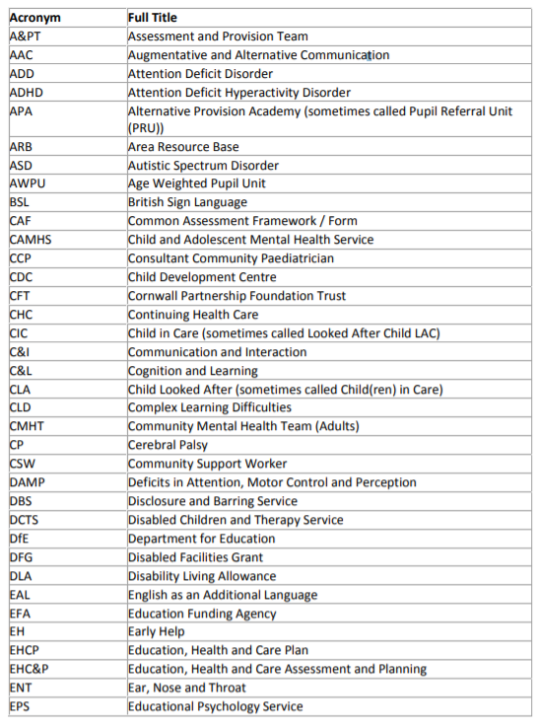
National and Local Acronyms

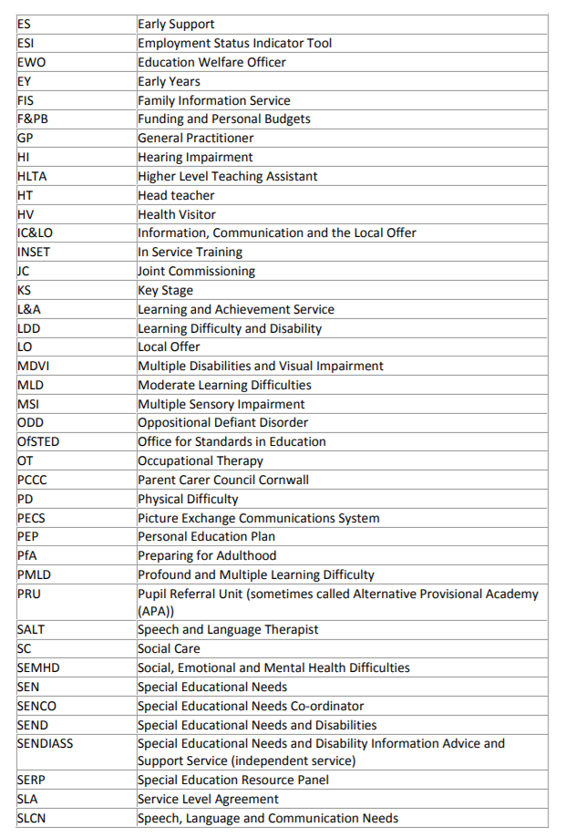
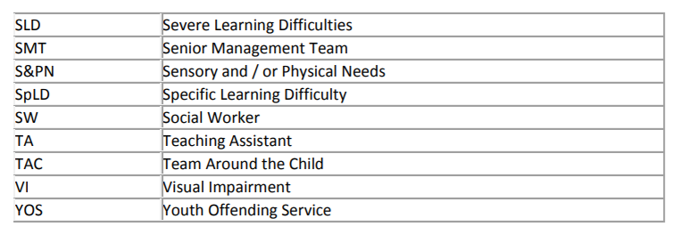

Headteacher: Mrs. I Bennett
Special Educational Needs and Disabilities Coordinator (SENDCO): Mr. T Wilson
twilson@cardinham.cornwall.sch.uk

